Educational Organisation Using ServiceNow

Team ID: NM2025TMID08667
Team Size: 1
Team Leader: VICEROY P

Abstract:
This project focuses on developing a ServiceNow-based automation system for educational institutions. It aims to simplify and centralize administrative and IT service requests. Manual processes are replaced with automated workflows to save time and reduce errors. The system ensures transparency, faster response, and easy tracking of requests. Overall, it enhances efficiency and improves service management within the institution.
Problem Statement:
Educational institutions face challenges in handling administrative and IT service requests efficiently. Manual processes cause delays, errors, and poor tracking of issues. There is no centralized platform to monitor requests from students and staff. Repetitive manual work reduces productivity and response time. A ServiceNow-based solution is needed to automate workflows and improve service management.
Objectives:
- To develop an automated service management system using ServiceNow for educational institutions.
- To streamline administrative and IT service requests through a centralized platform.
- To reduce manual effort and improve accuracy in request handling.
- To enhance transparency and tracking of service progress for students and staff.
- To ensure faster response, better communication, and improved operational efficiency.
Scope:
- The project focuses on automating service management processes within educational institutions using ServiceNow.
- It covers handling of administrative, IT, and support-related requests from students and staff.
- Future enhancements may include integration with email notifications and analytics for performance tracking.
Phases of Project:
1. Ideation Phase
- Need Identification: The project began by recognizing the need to automate service requests and IT management in the educational institution.
- Problem Analysis: Existing manual methods were found to be slow, error-prone, and lacking proper tracking mechanisms.
- Platform Selection: ServiceNow was chosen for its flexibility, cloud-based structure, and ability to automate workflows effectively.
- Goal Definition: Key goals were set to improve transparency, reduce manual work, and provide faster service delivery.
- Concept Development: Preliminary ideas on modules, user access levels, and workflows were discussed and finalized.
2. Project Planning Phase
- Timeline Creation: A detailed schedule was designed, covering design, development, and testing phases.
- Team Roles: Specific roles were assigned for analysis, design, implementation, and documentation.
- Tool Selection: Required ServiceNow modules and features were selected for automation purposes.
- Resource Planning: Necessary data, system access, and user requirements were planned in advance.
- Milestone Setup: Clear milestones were established to track project progress and ensure timely completion.

3. Project Design Phase
- System Architecture: A detailed architecture was created showing user interactions and system components.
- User Interface Design: Simple and clear interfaces were designed for students, staff, and administrators.
- Database Structure: Tables and fields were planned for storing and managing request data efficiently.
- Workflow Automation: Business rules and flow designers were created to automate request handling.
- Design Validation: The design was reviewed with stakeholders to ensure accuracy and functionality.
4. Requirement Analysis
- Requirement Gathering: Feedback was collected from students, staff, and management to identify needs.
- Functional Definition: Core functionalities like ticket creation, tracking, and resolution were finalized.
- Technical Requirements: Hardware, software, and network requirements were clearly documented.
- Feasibility Study: The requirements were analyzed for practicality and alignment with ServiceNow features.
- Documentation: All requirements were compiled to guide the development and testing process.

5. Performance Testing
- Testing Process: The system was tested for speed, reliability, and response under real time conditions.
- Workflow Verification: Automated processes and service flows were checked for accuracy and consistency.
- Load Testing: The system’s performance under multiple simultaneous requests was evaluated.
- Error Correction: Detected bugs and issues were fixed to improve stability and efficiency.
- Final Validation: The system was validated for user satisfaction and institutional performance standards.

Project Implementation Steps:
- Setting up ServiceNow Instance
- Creating an Update Set
- Creating a Table
- Creating Salesforce Table
- Creating Admission Table
- Creating student Progress Table
- Form Layout
- Form Design
- Creating Form Design for Salesforce Table
- Creating Form Design for Admission Table
- Creating Form Design for Student Progress Table
- Number Maintenance
- Process Flow
- Client Script
- Result

- Setting up ServiceNow Instance
- Sign up for a developer account on the ServiceNow Developer site “https://developer.servicenow.com”.
- Once logged in, navigate to the "Personal Developer Instance" section.
- Click on "Request Instance" to create a new ServiceNow instance.
- Fill out the required information and submit the request.
- You'll receive an email with the instance details once it's ready.
- Log in to your ServiceNow instance using the provided credentials.
- Now you will navigate to the ServiceNow.
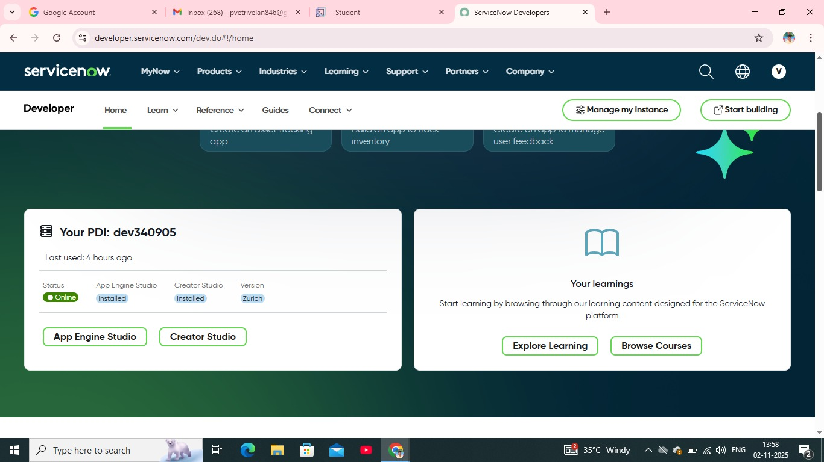
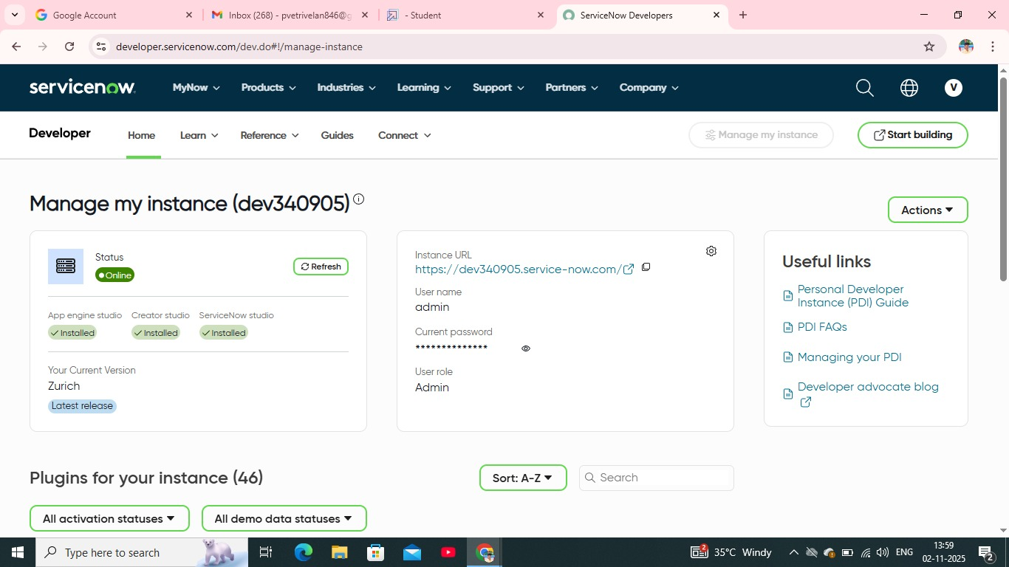

- Creating an Update Set
- Click on All >> Local update sets.
- Click on New.
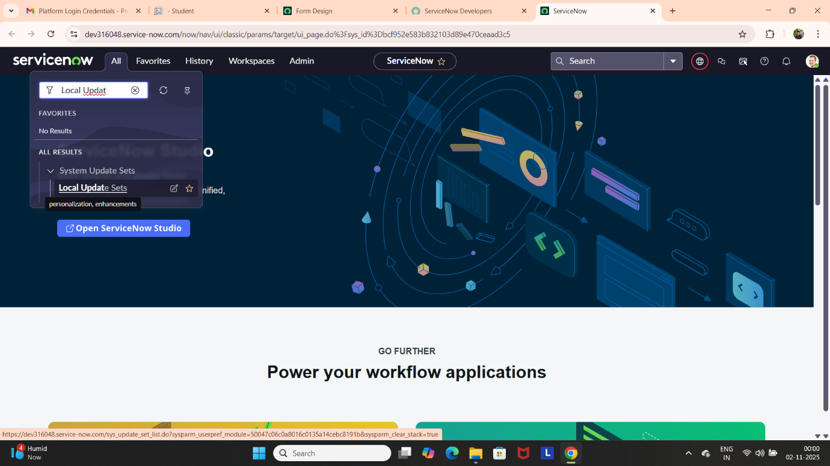
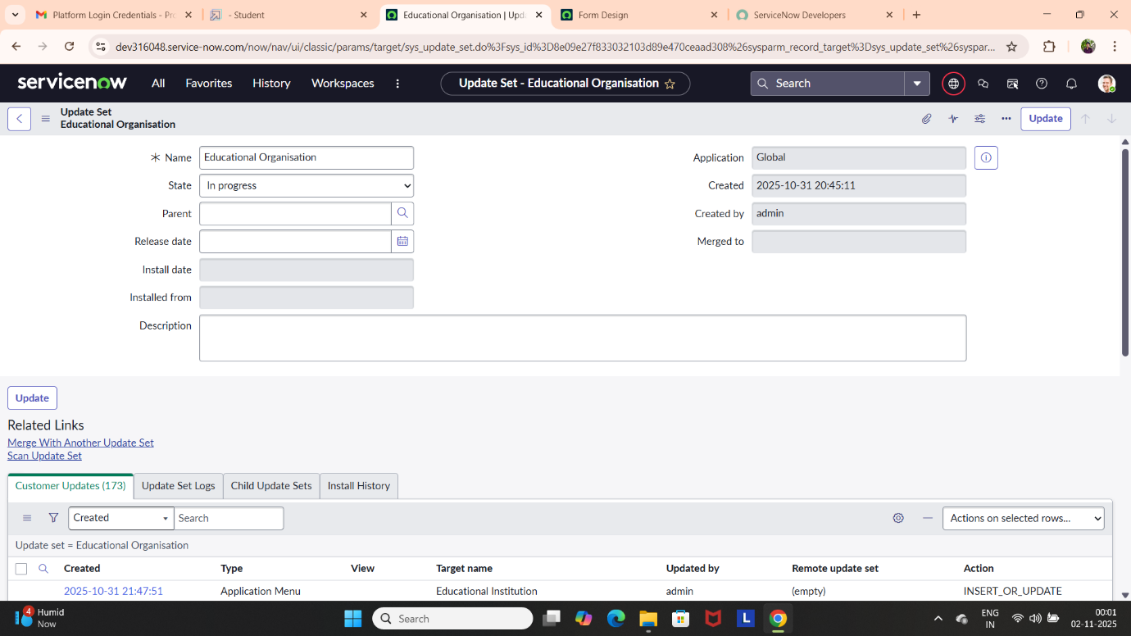
- Enter the Details Name: Educational Organisation >> Click on Submit and make Current.

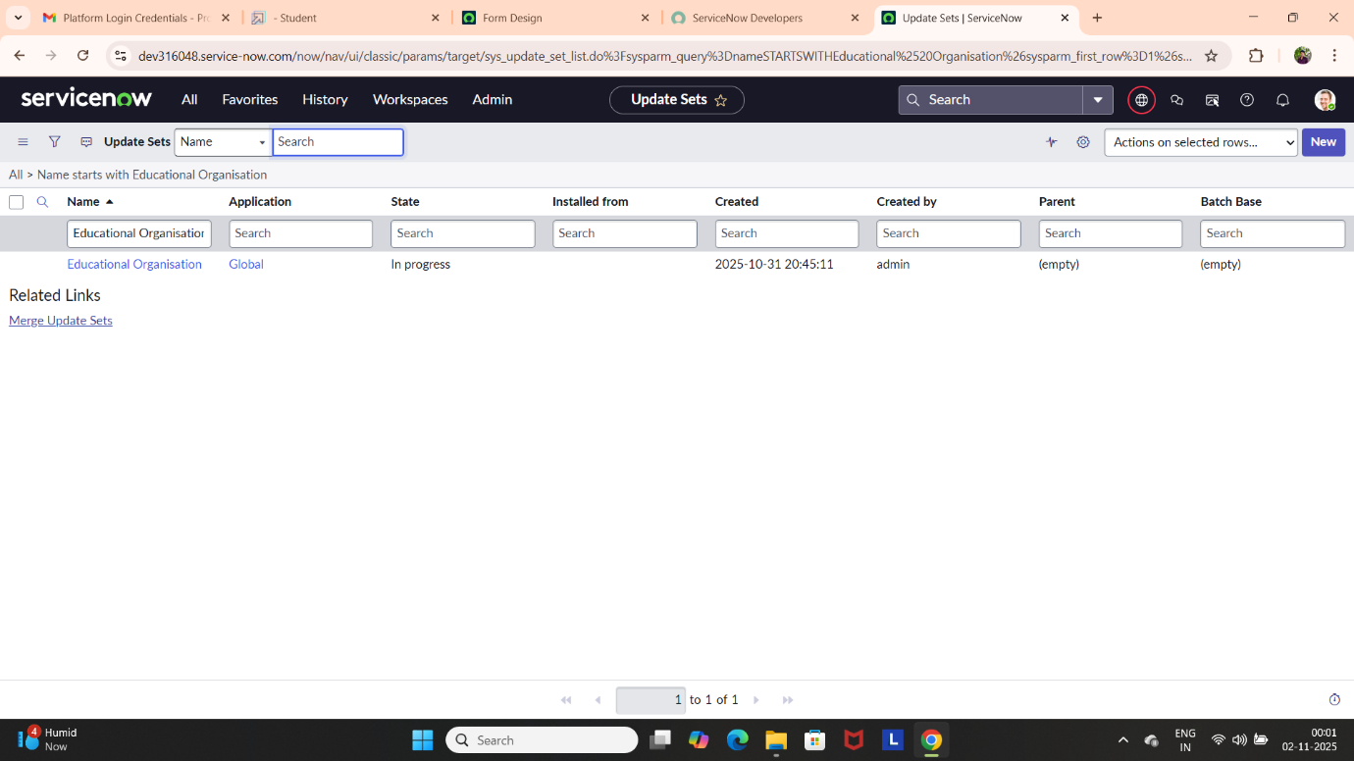

- Creating a Table

Creating a Salesforce Table.

- All >> Tables.
- Click on new.
- Enter the Label (Anything you want): Salesforce >> Click on Name it will Automatically generate Api name.
- Create columns as given below, Double Click on Column label and Enter the Column labels and click on the tick mark >> Give Type as given.
- For “Admin Number” Give Display as True and right click on the toggle bar on top >> save.
- Click on controls >> Enable Extensible.
- Click on “Admin Number” column, In Related Links Click on Advanced View >> Default View (Enable Use dynamic default) >> select Get Next Padded Number in Dynamic default value >> Update.
- Click on “Grade” Column >> Click on Choices and give Label, Value and Sequence as given below.

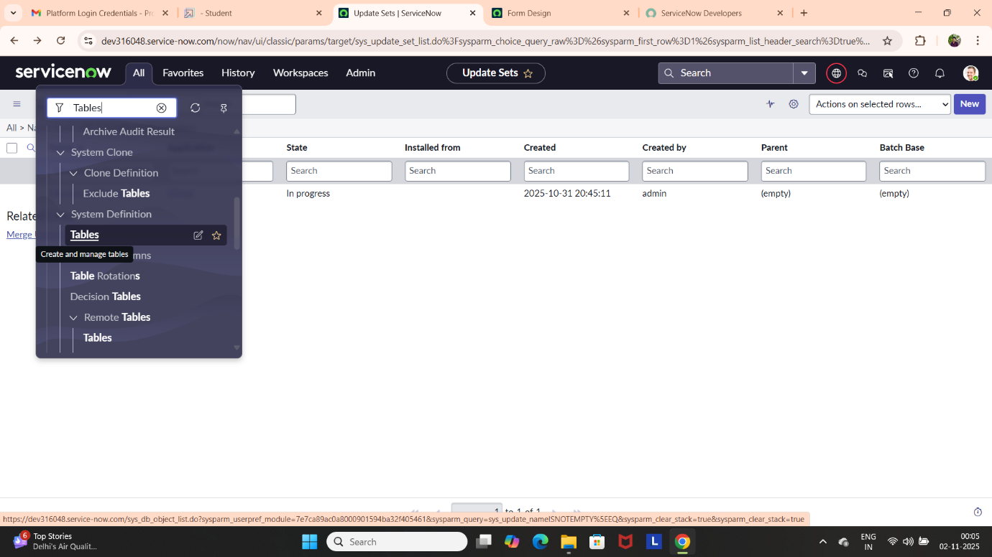
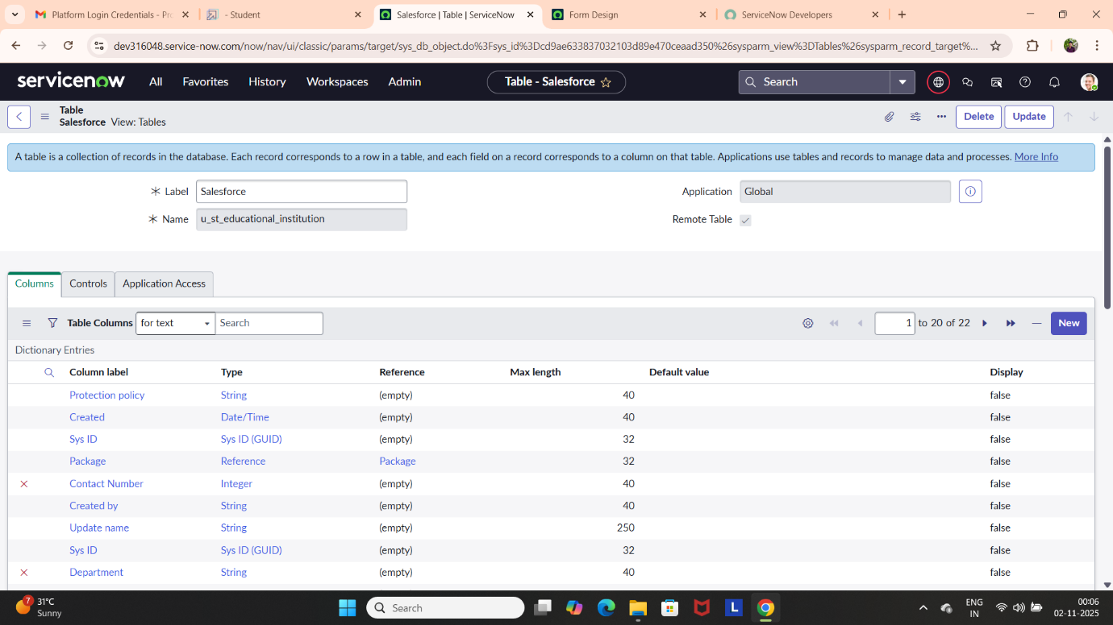
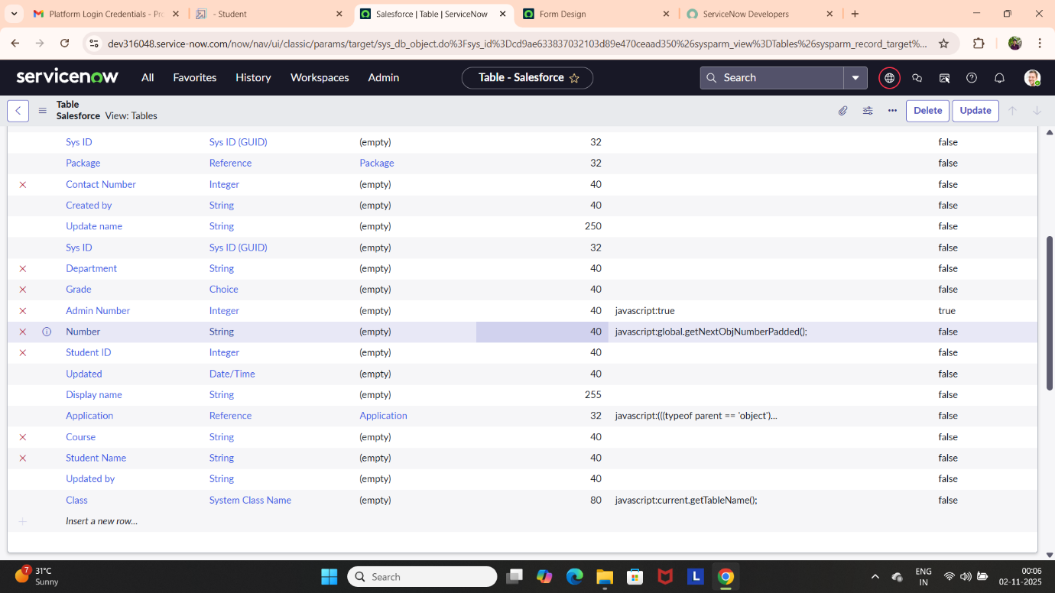

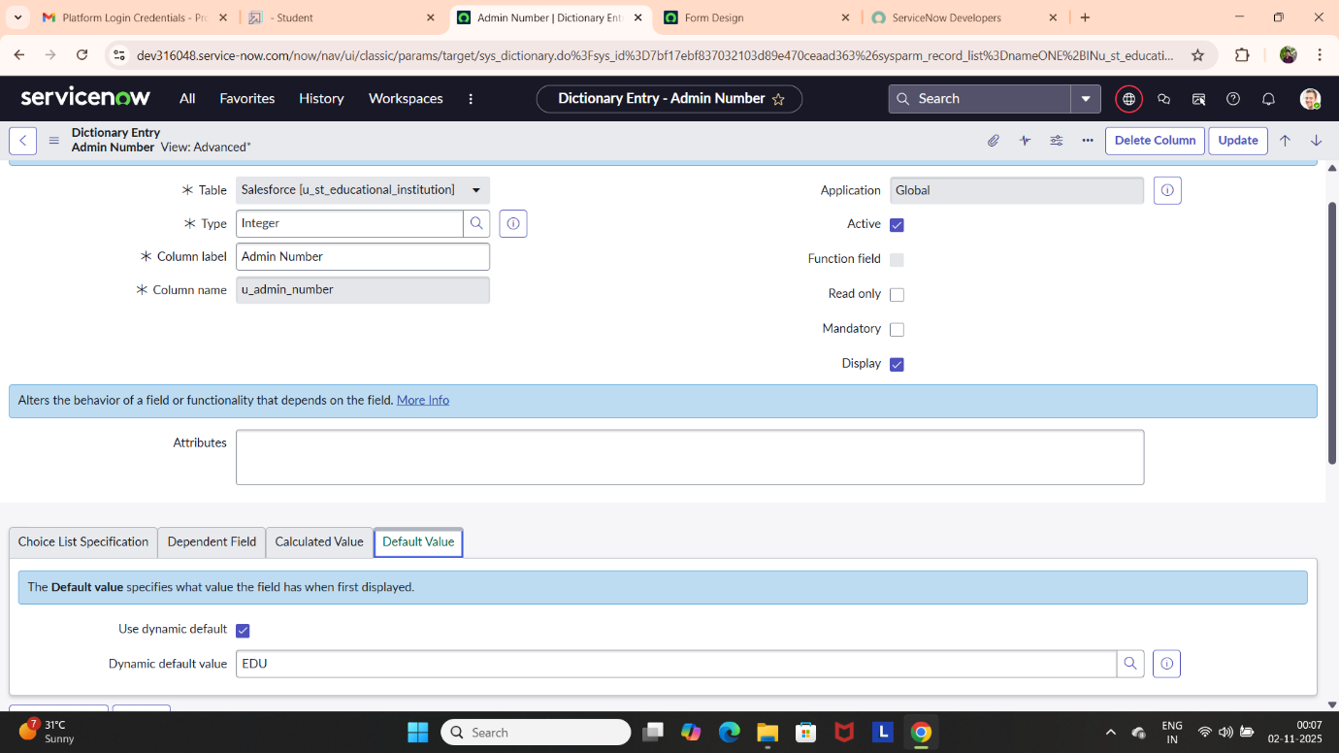
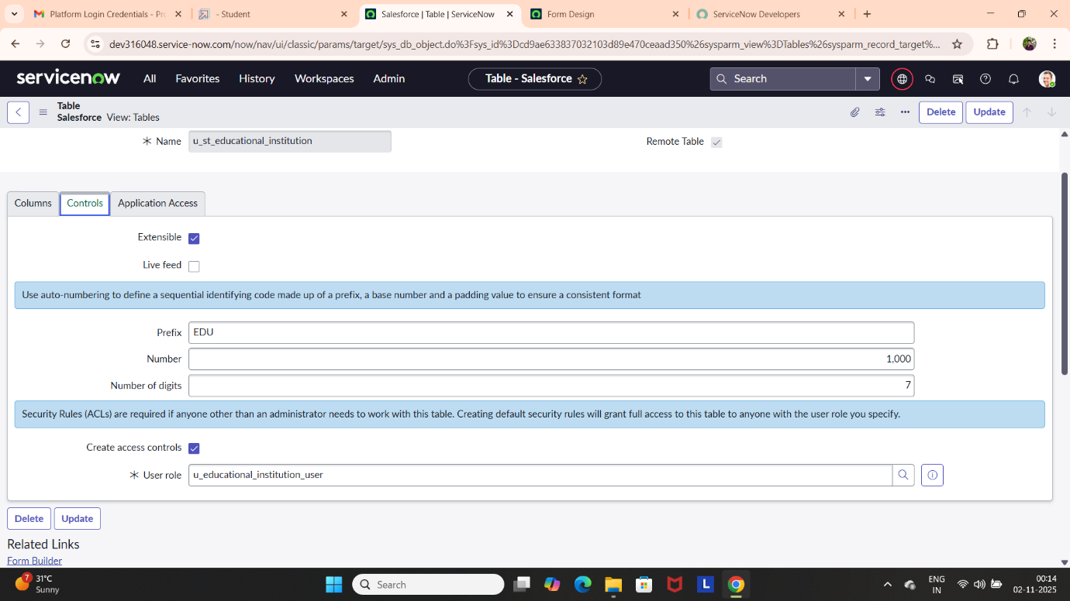

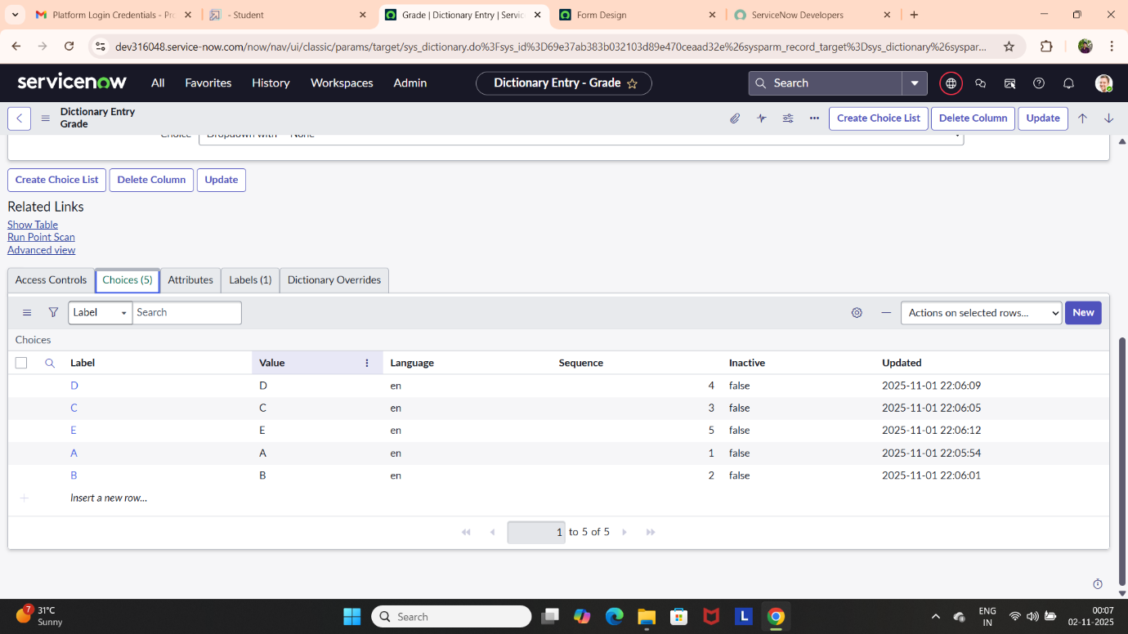

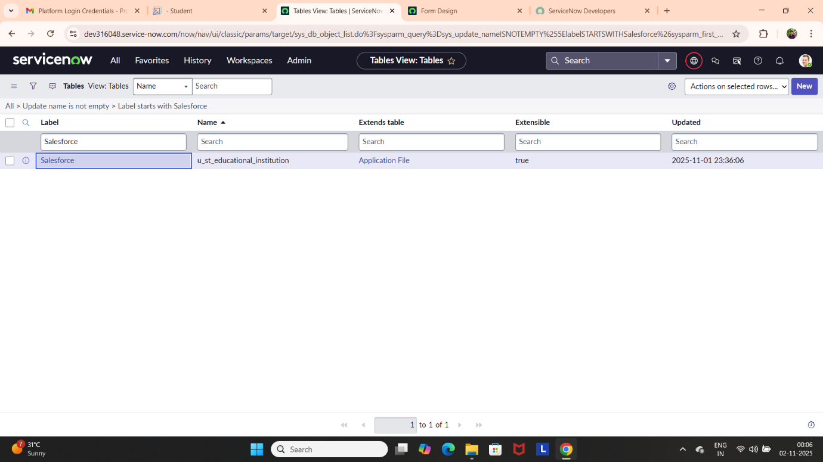

Creating an Admission Table
- Create an Admission Table with Columns given.
- Select Extends Table >> Salesforce and also Select Add module to menu >> Salesforce
- Create Fields as Shown
- Create choice for Admin Status
- Create choice for Pin code
- Create choice for Purpose of join
- Create choice for School
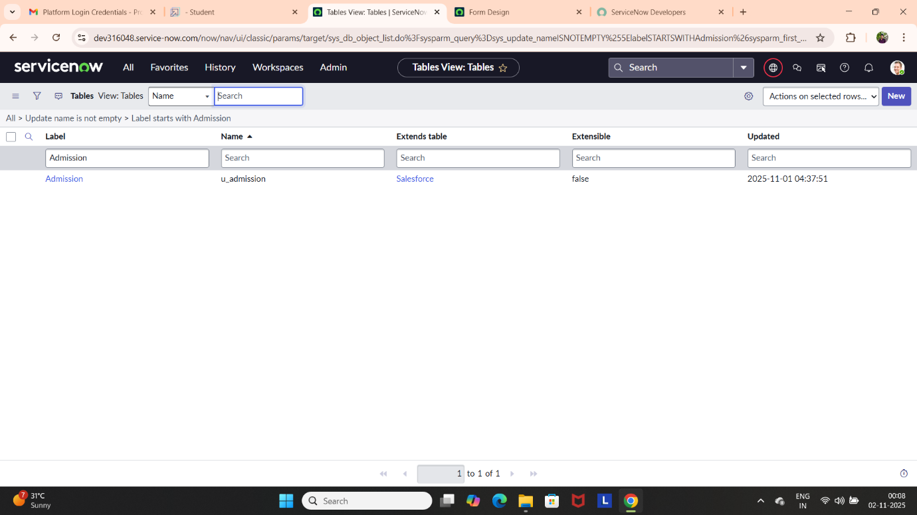
- Create choice for School Area
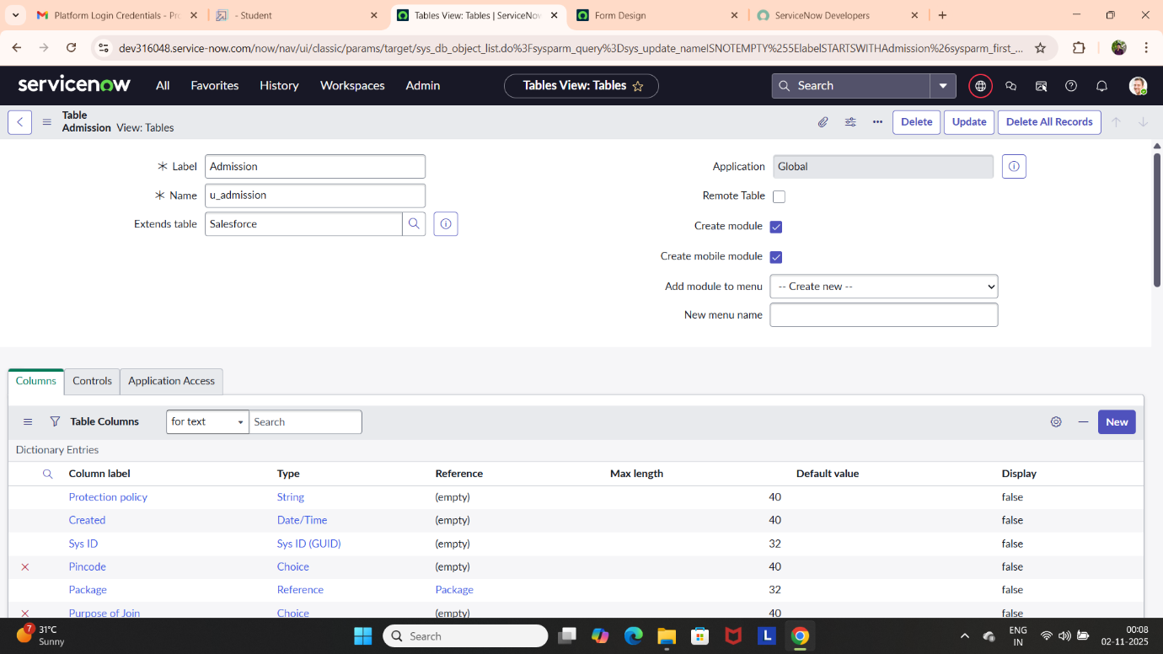
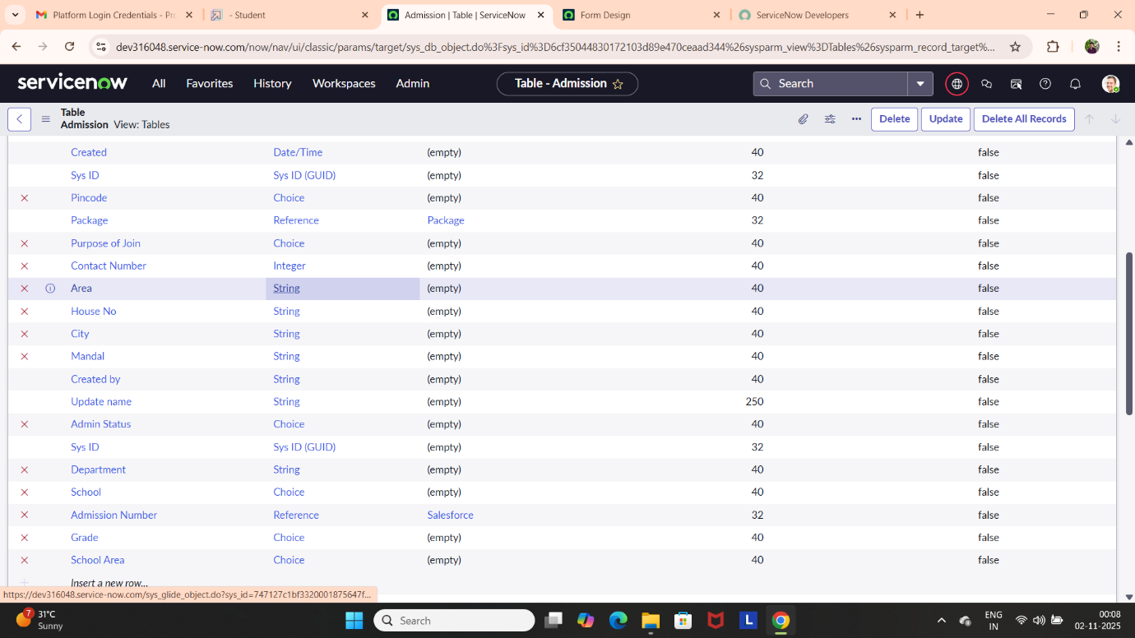

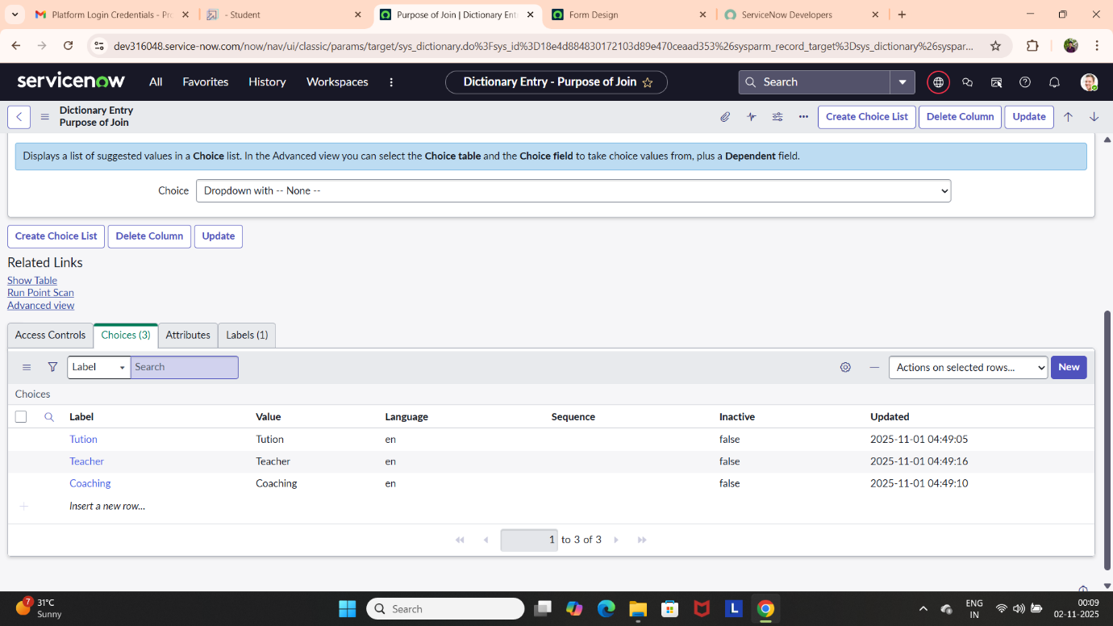

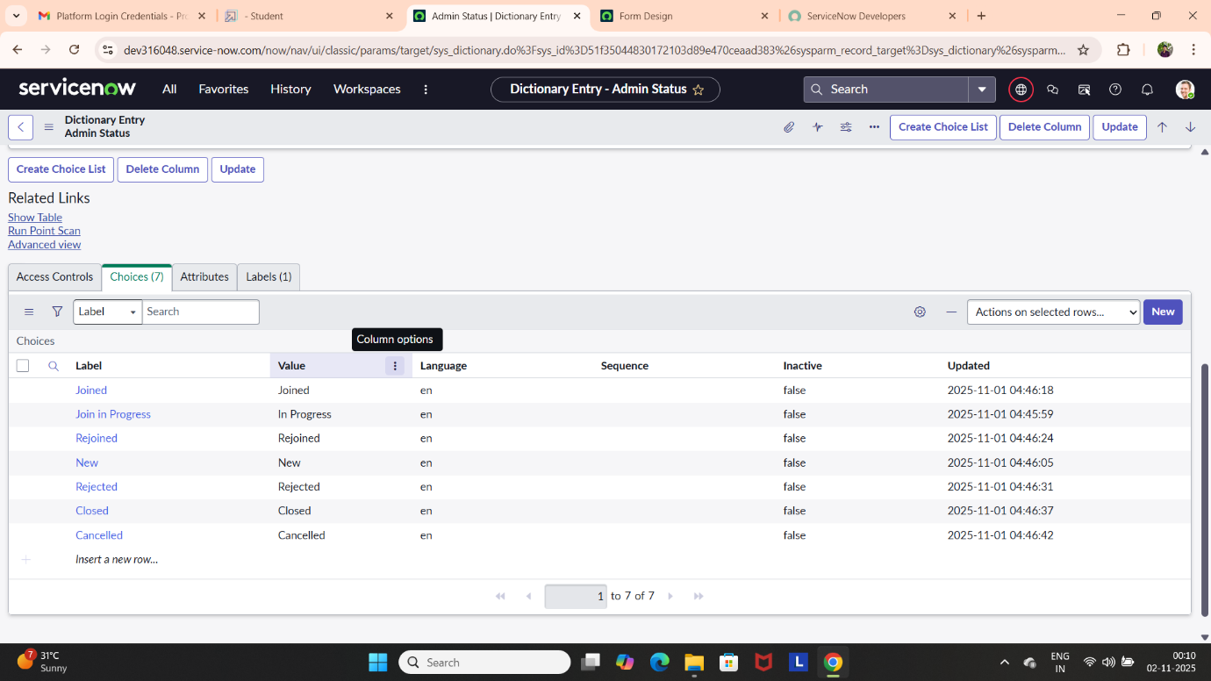

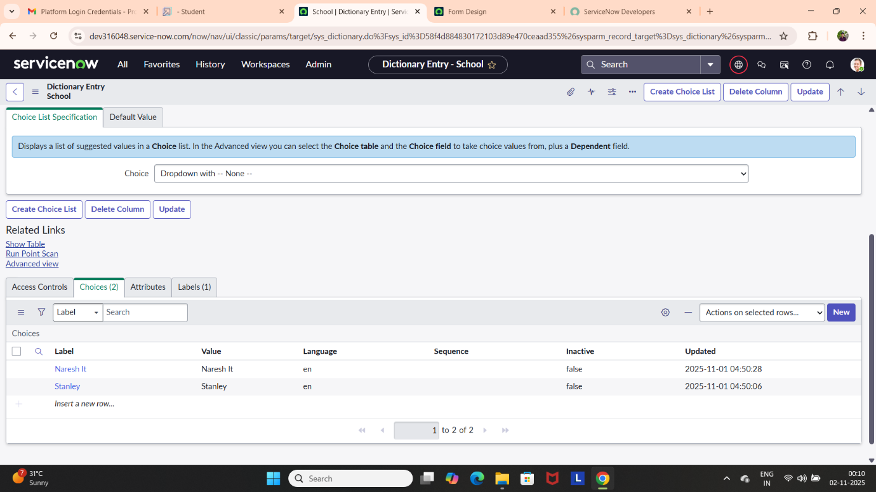

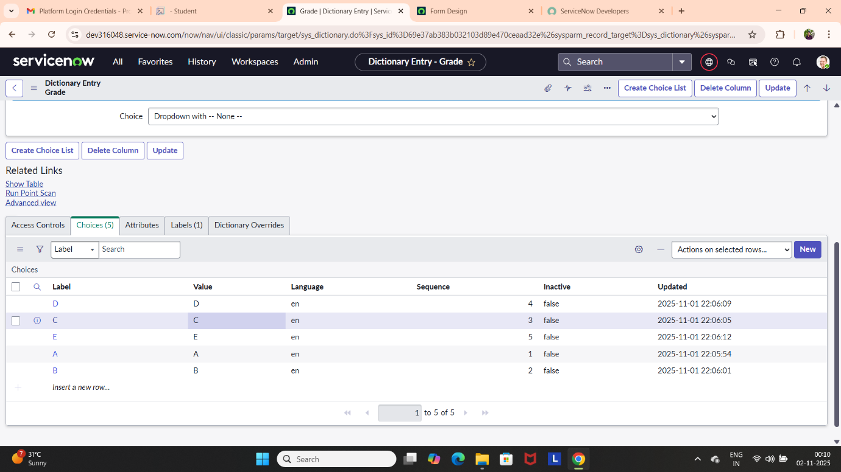

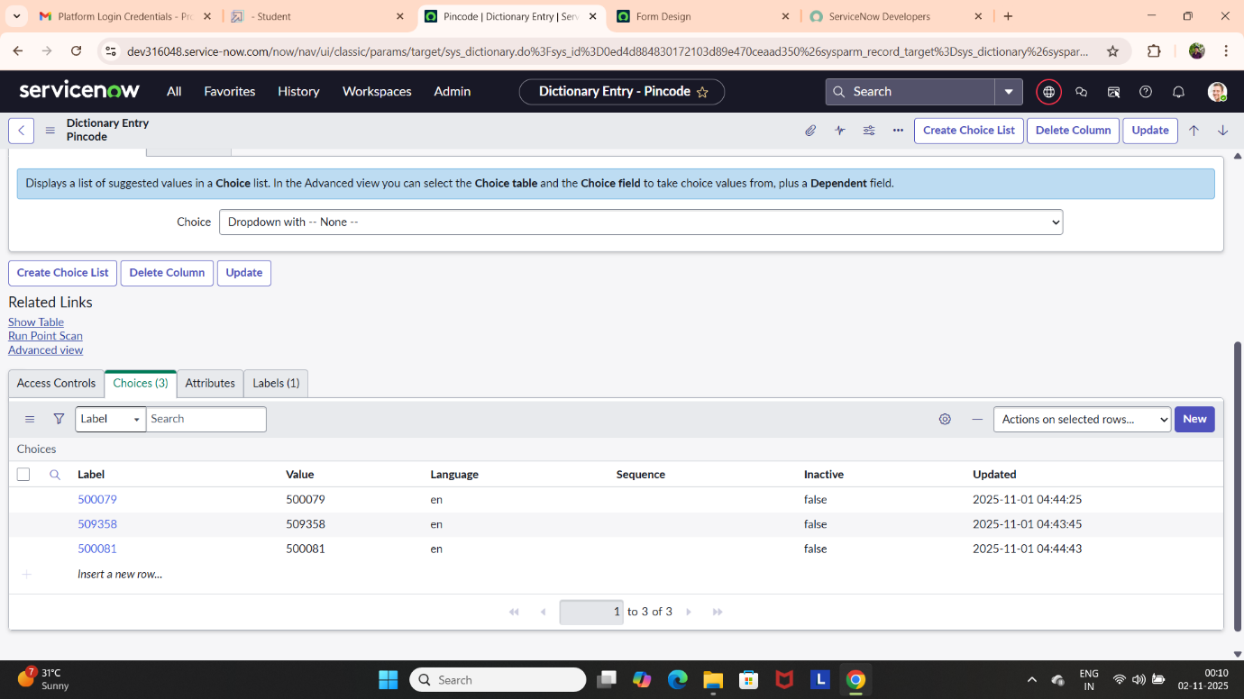

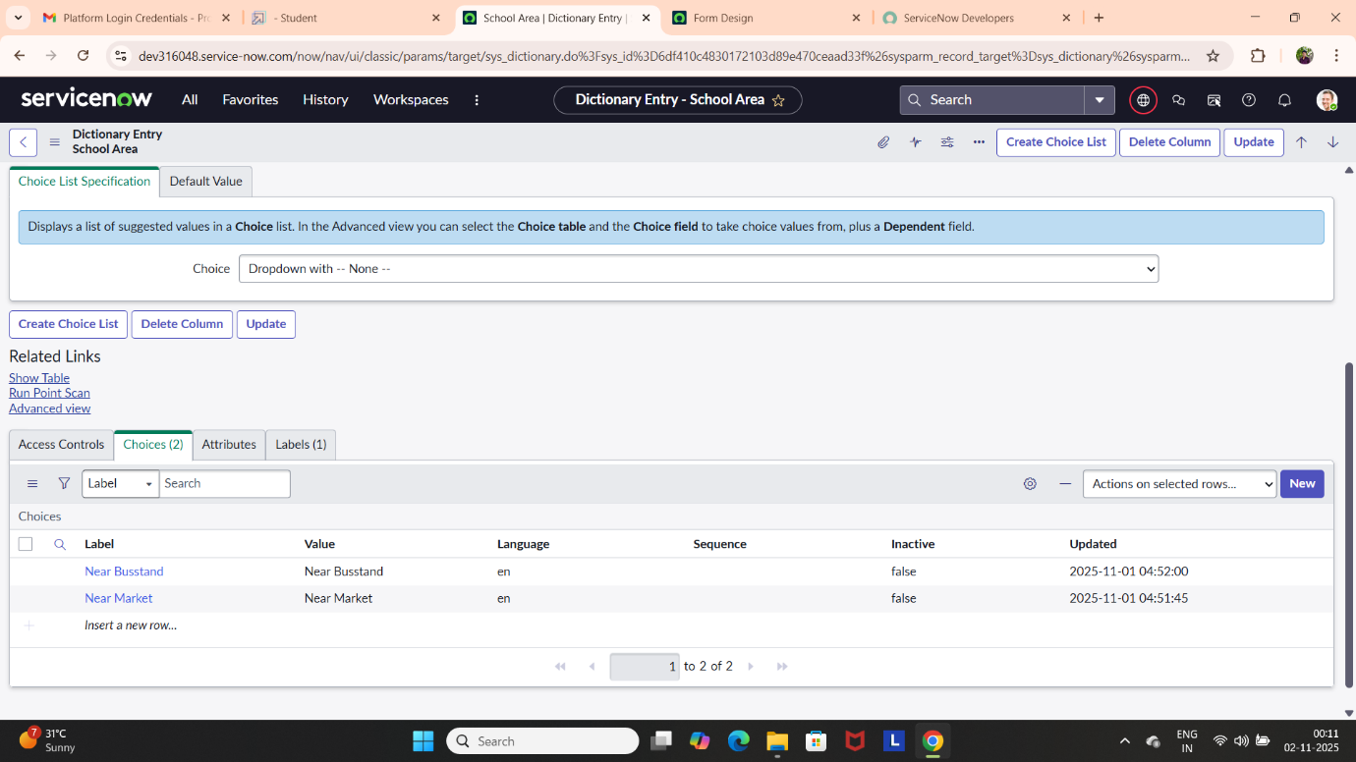

Creating a Student Progress Table
- Create a Student Progress Table with Columns given
- Select Add module to menu >> Salesforce
- Create Fields as Shown:
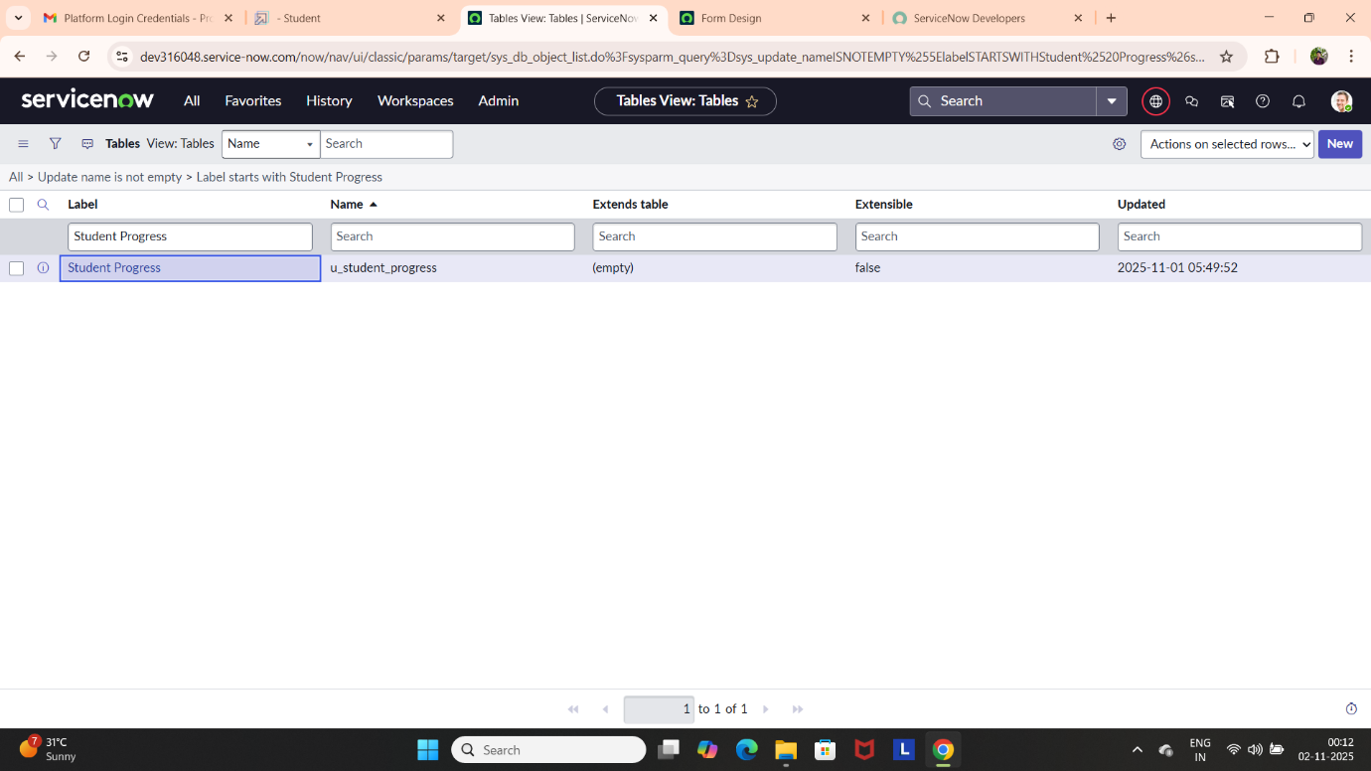

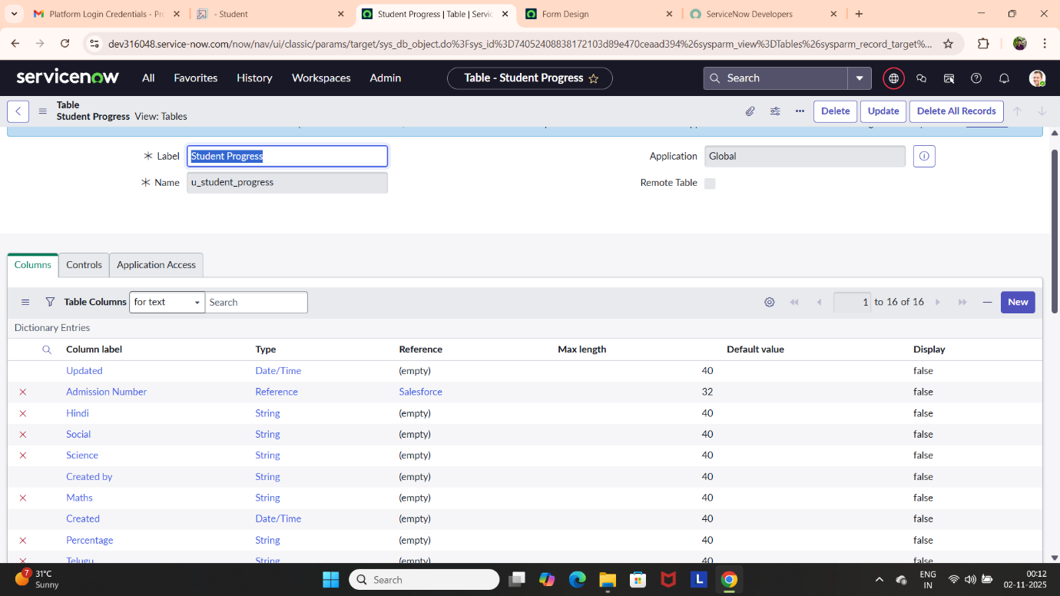

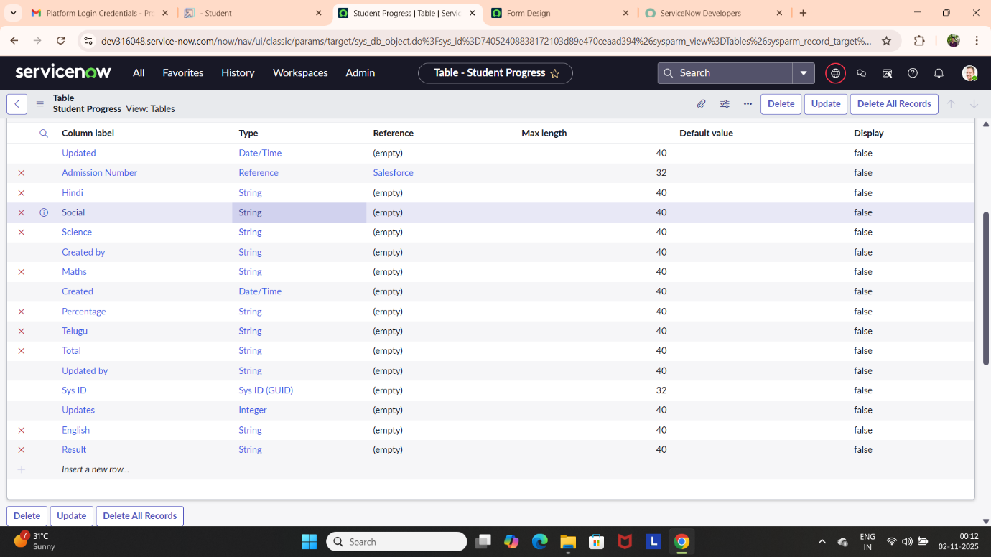
- Form Layout

Configuring Table form for Student Progress Table
- In the Student Progress Table Page, Click on Layout form.
- Click on Admission Number [+].
- Select below Admission Number fields in Available side and send it to selected side as below >> save.
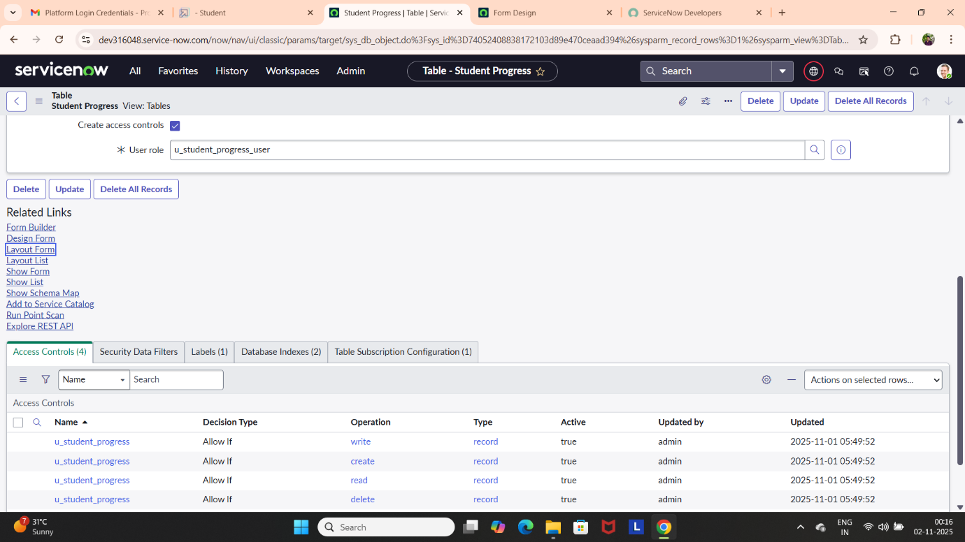

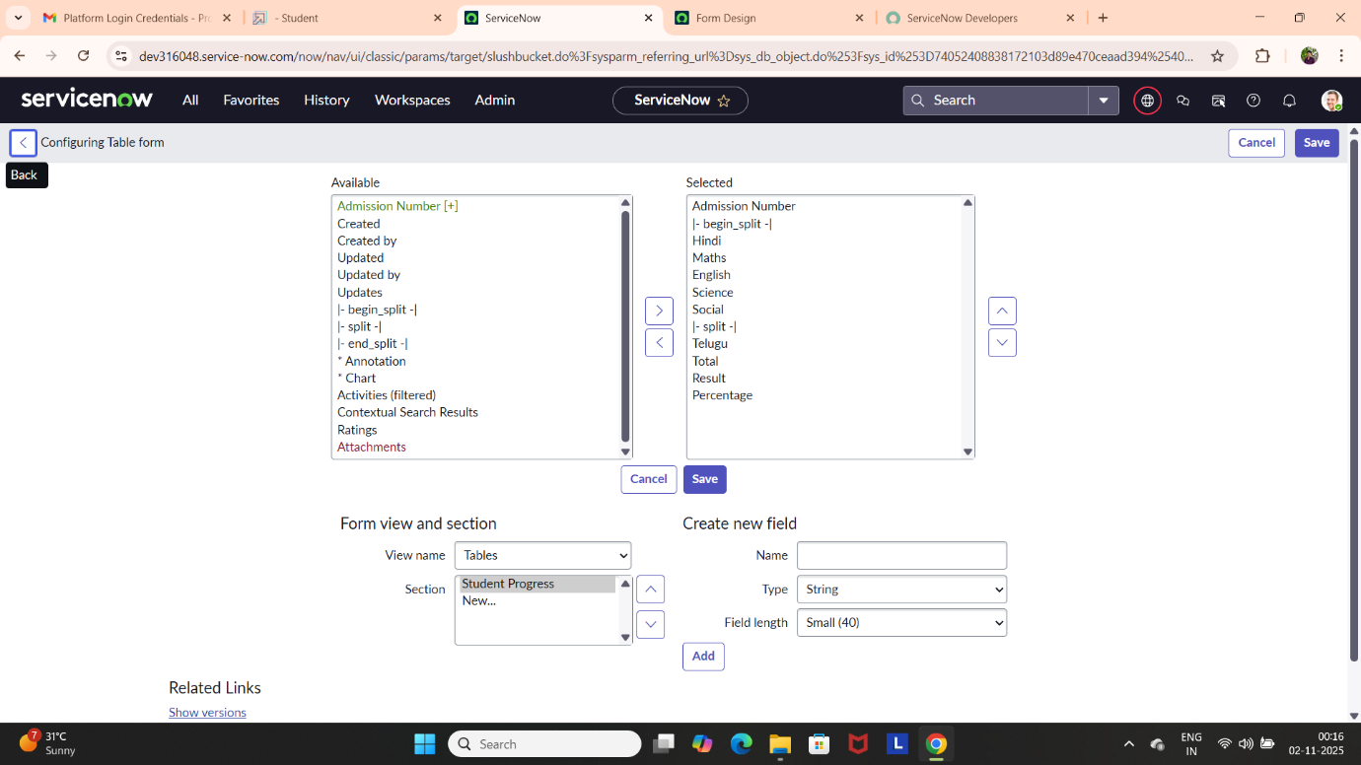
- Form Design
Creating Form Design for Salesforce Table
- All >> System Definition >> Tables.
- In Label Search for Salesforce and open.
- Right Click on top Toggle >> Configure >> Form Design.
- In drop down select Salesforce(u_salesforce).
- Drag and drop the fields to the left side as below.
- Save
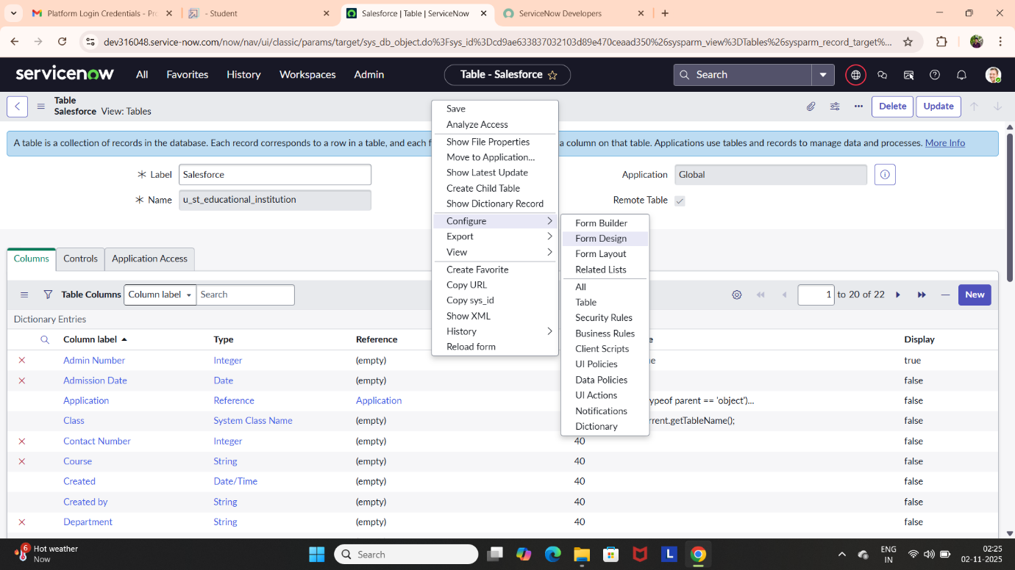

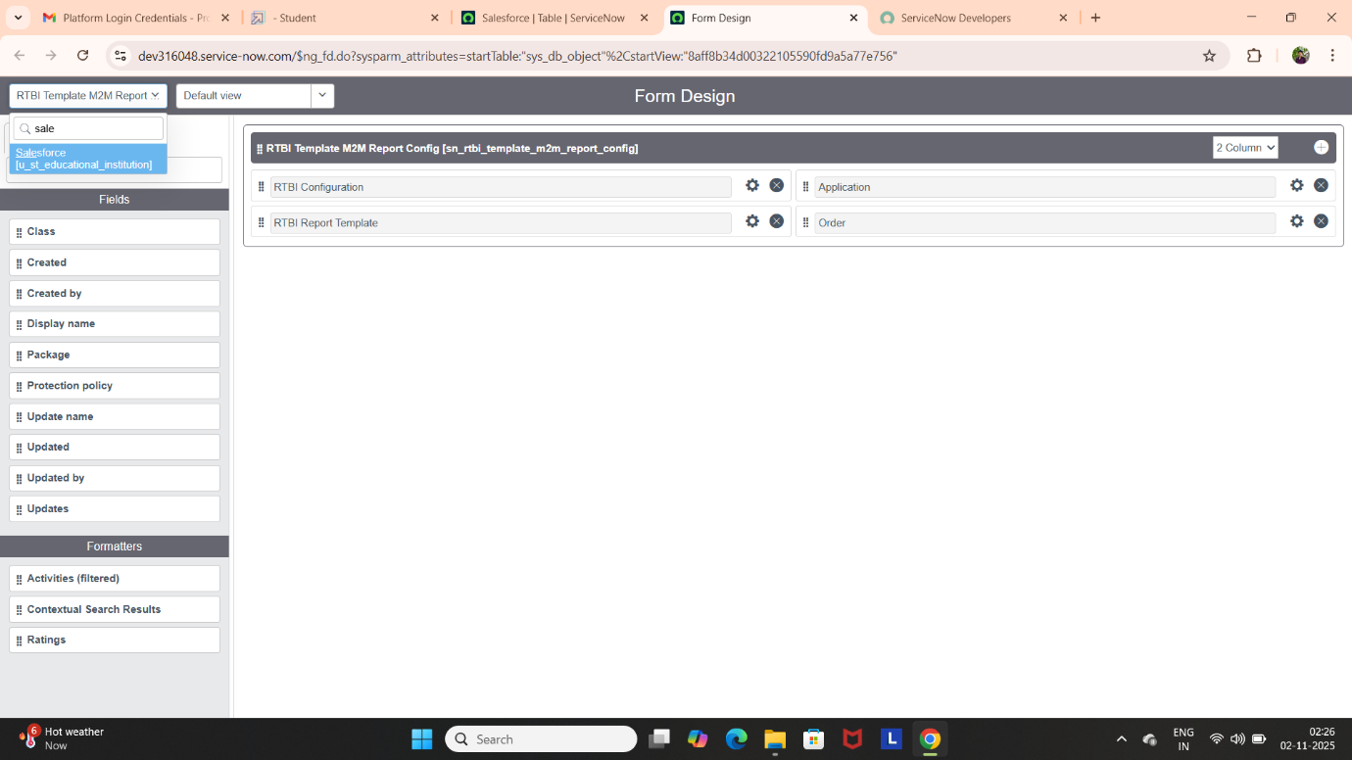

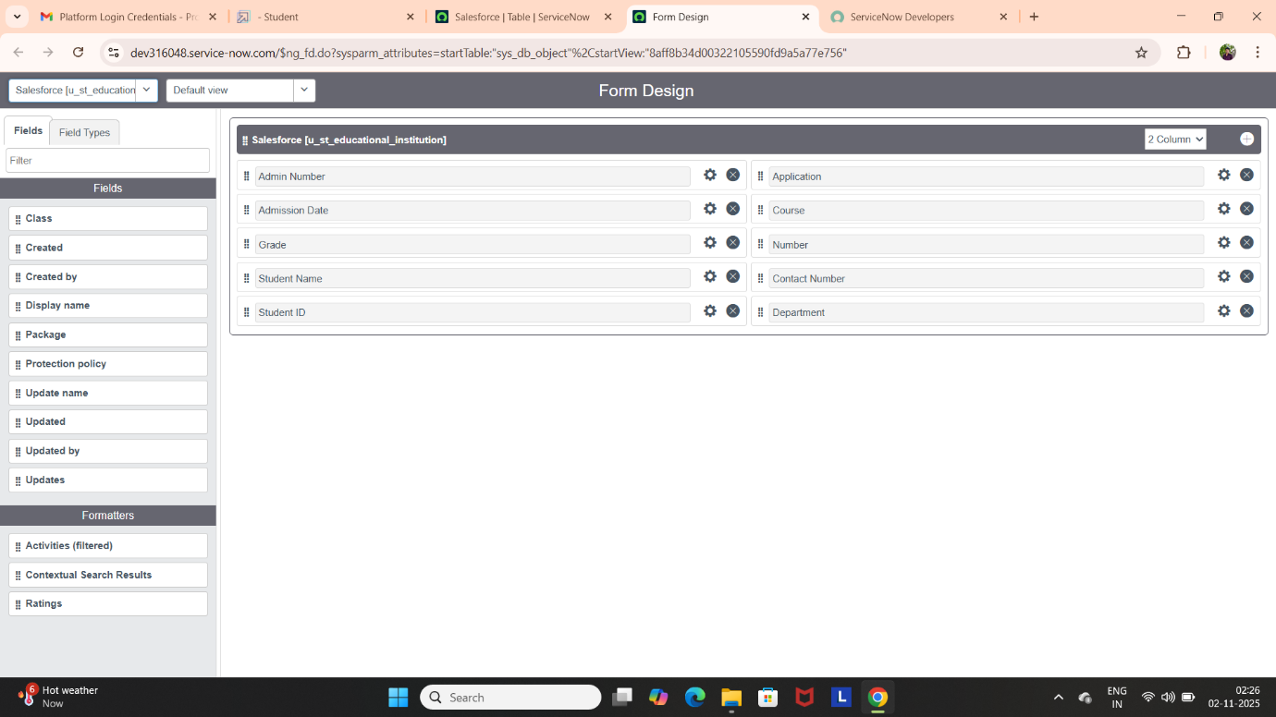

Creating Form Design for Admission Table
- Follow the same steps as Activity1, Configure the fields as below and save.
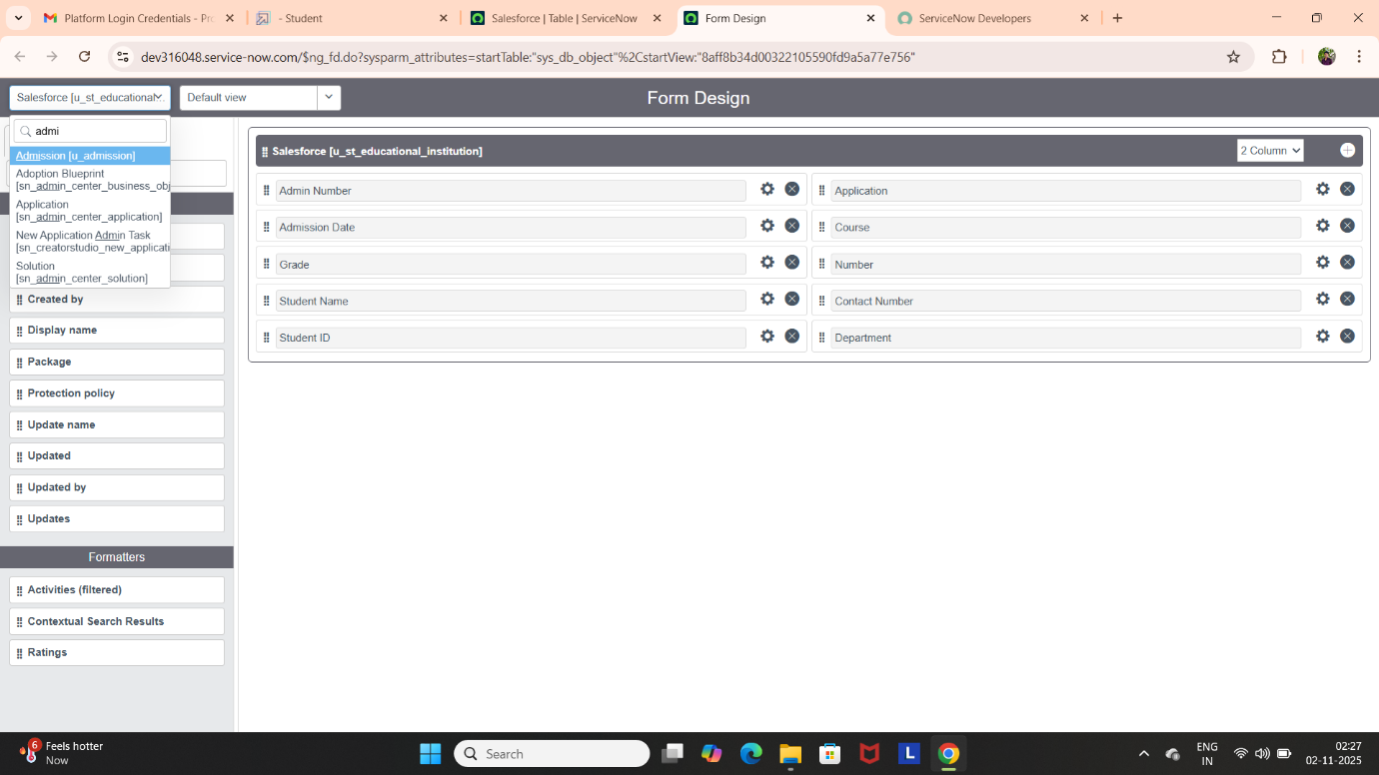

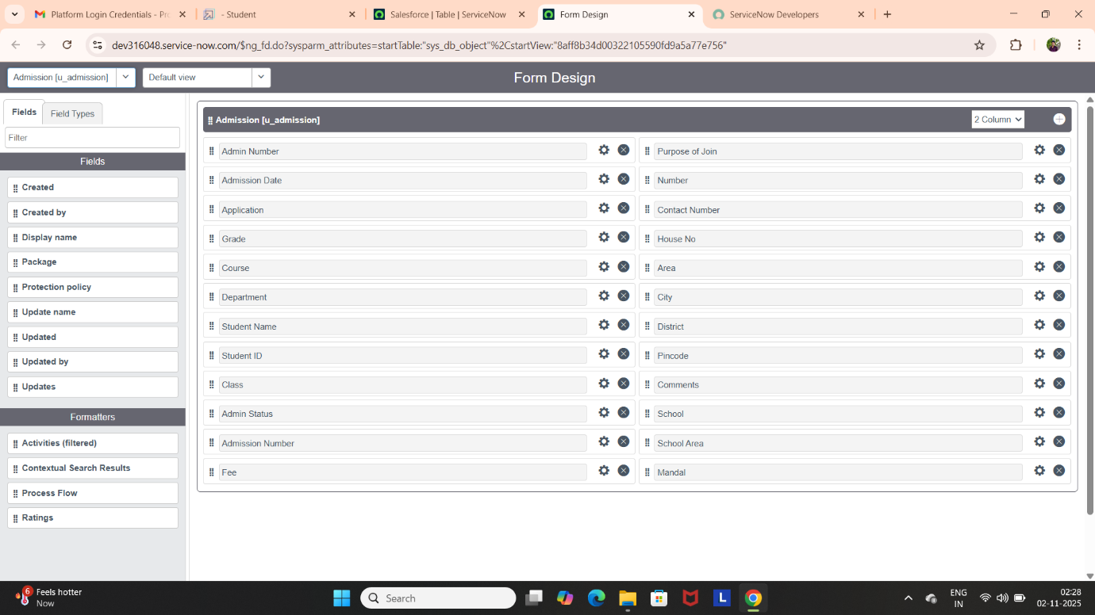

Creating Form Design for Student Progress Table
- Follow the same steps as Activity1, Configure the fields as below and save.
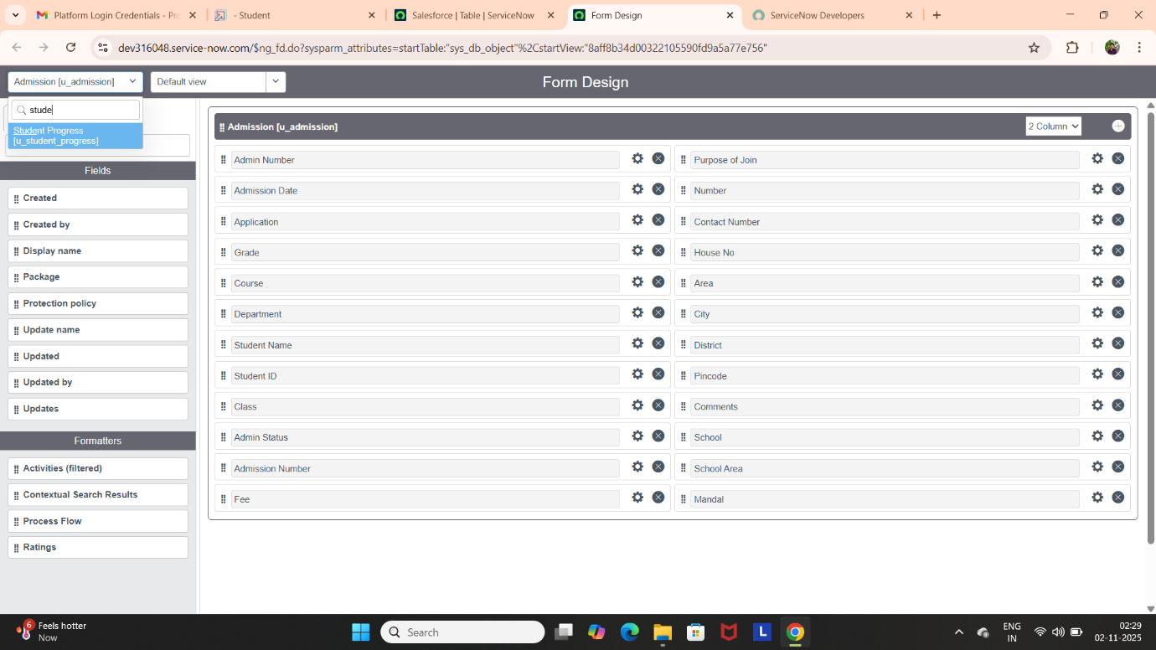

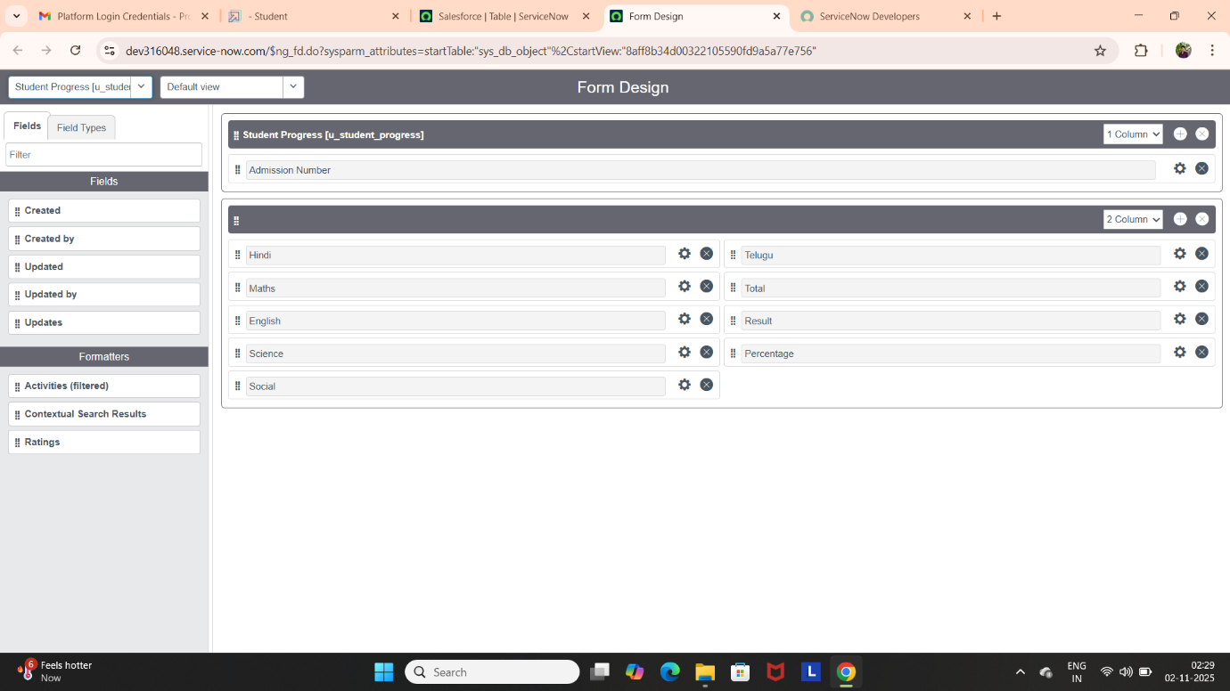

- Number Maintenance

Creating Number Maintenance for Admin Number
- All >> Number Maintenance >> New.
- Fill the Details >> Submit.
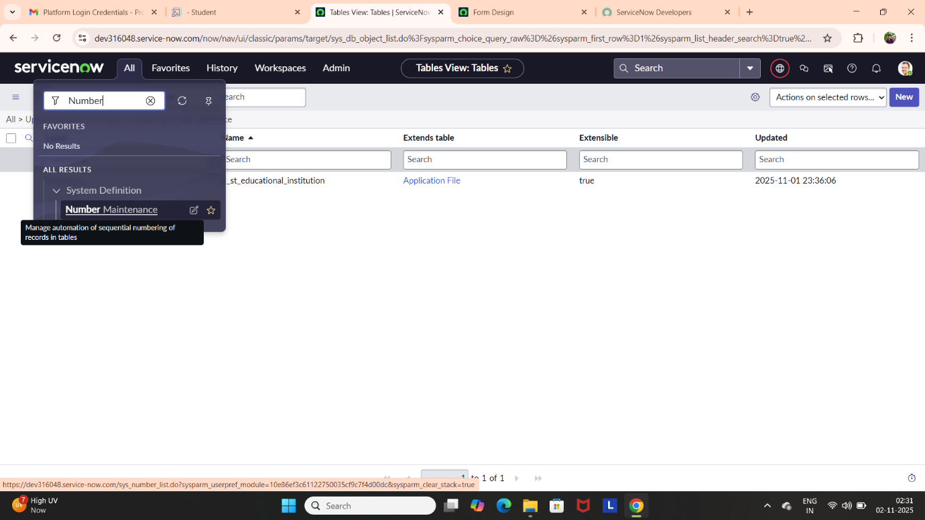

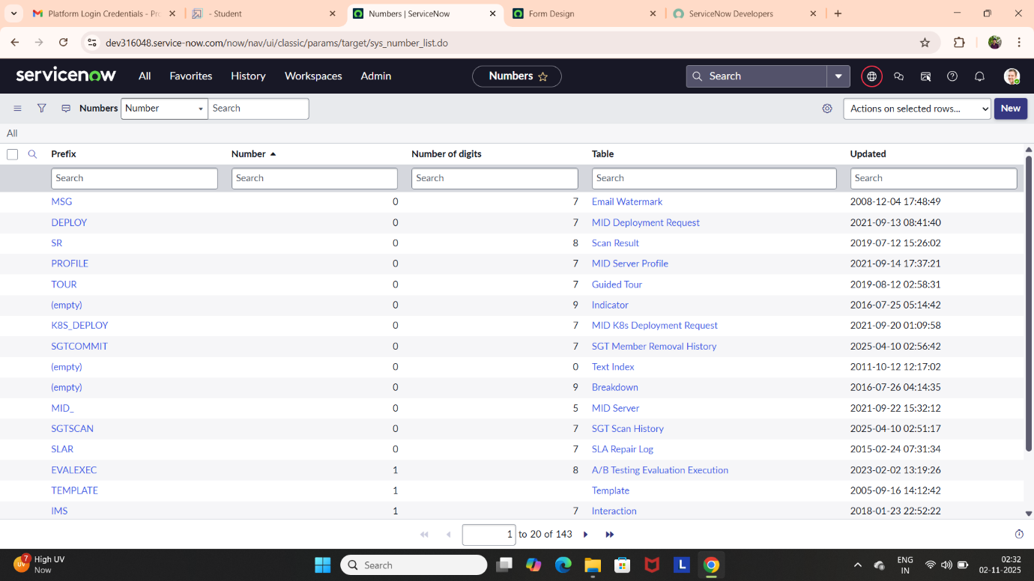

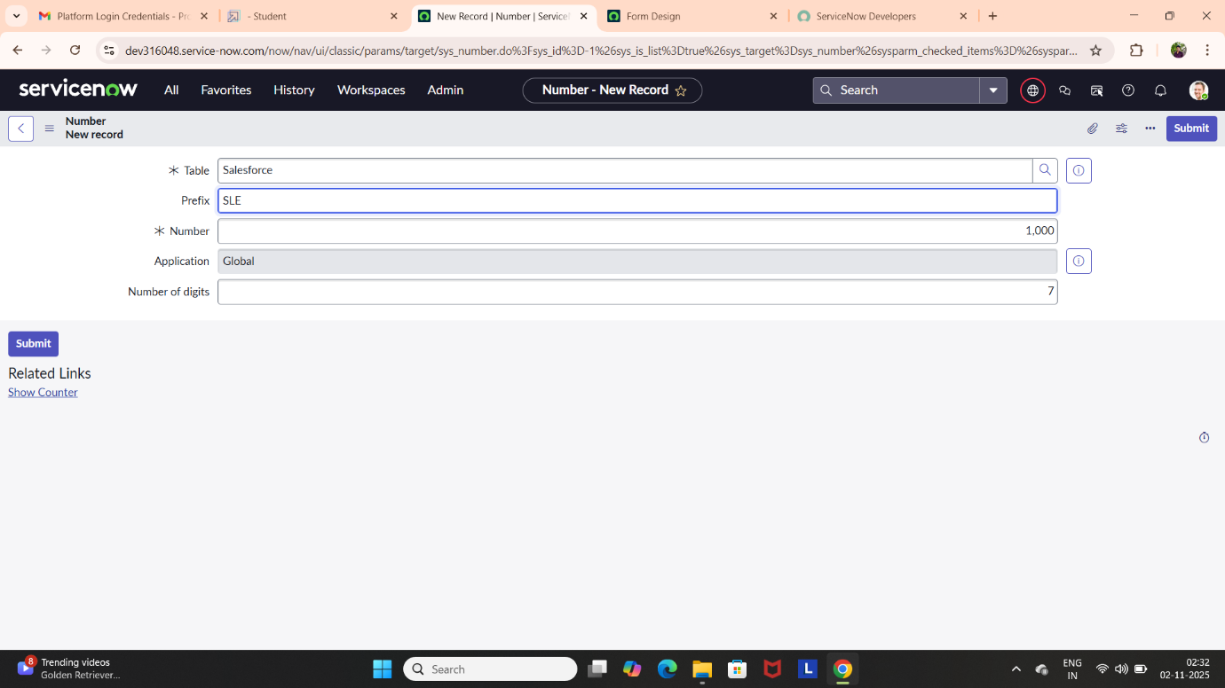

- Process Flow
Creating Process Flow for Admission Table
- All >> Process Flow>> New.
- Fill the Details as given Below
- Right Click on toggle and click on the save.
- Replace the Name and Label as below and click on Insert on stay. Order should be New >> InProgress >> Joined >> Rejected >> Rejoined >> Closed >> Cancelled.
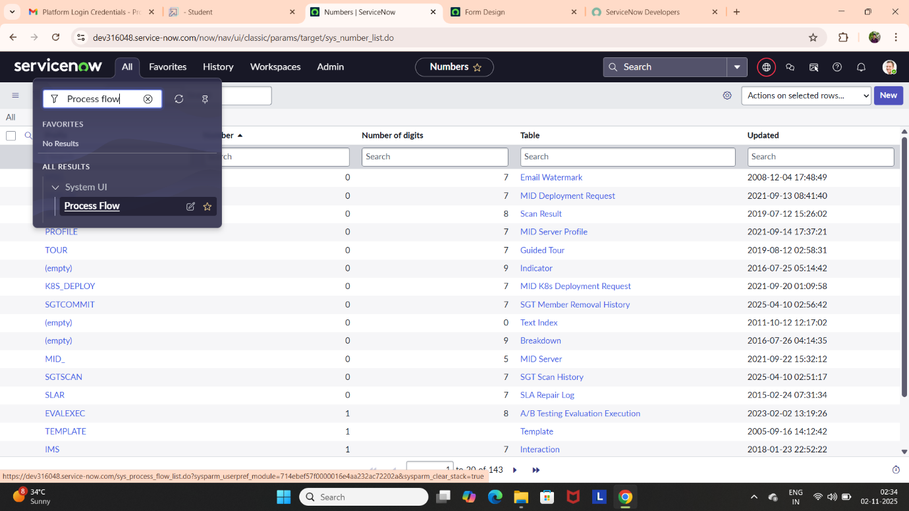

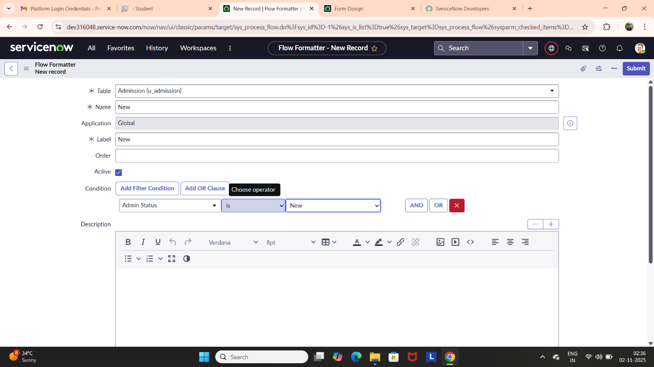

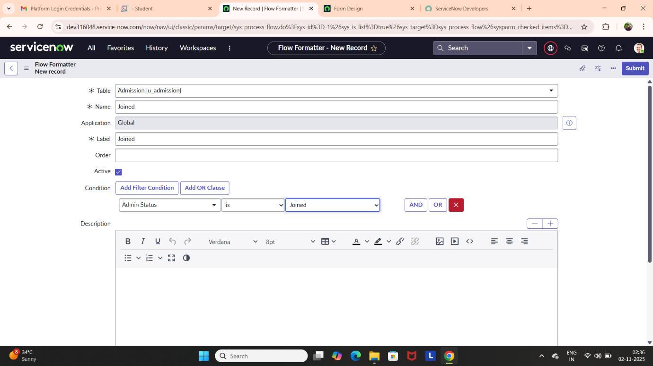

- Client Script
Creating “Auto populate” Client Scripts for Admission Table
- All >> Client Scripts >> New.
- Write the code, Enable Isolate Script and Save.
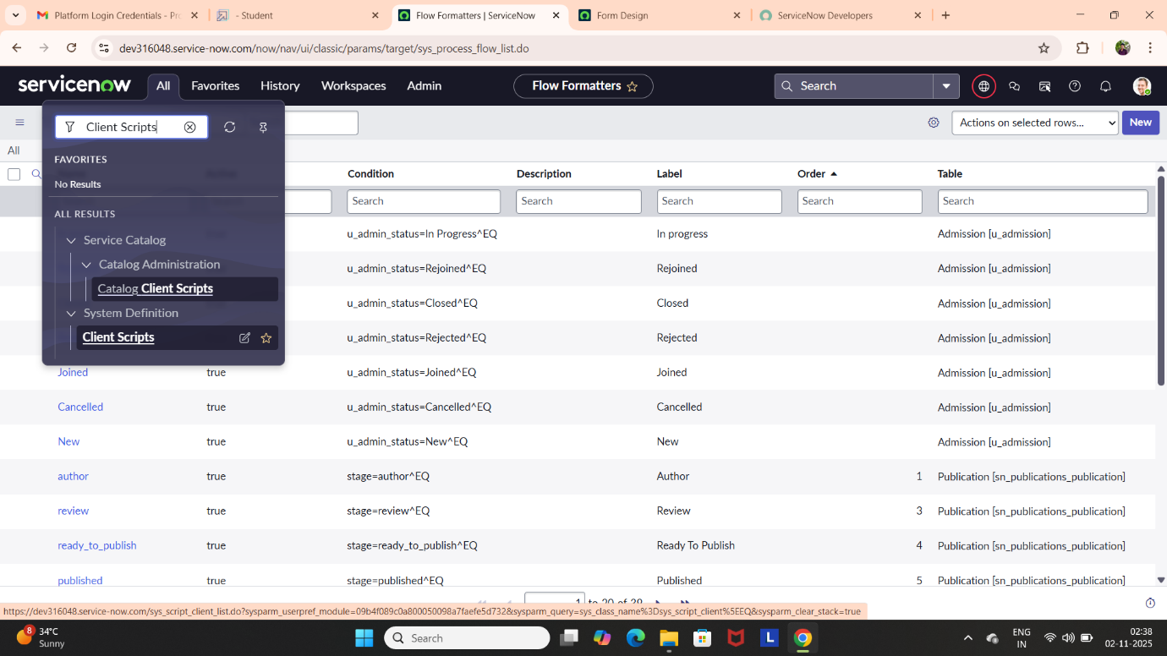
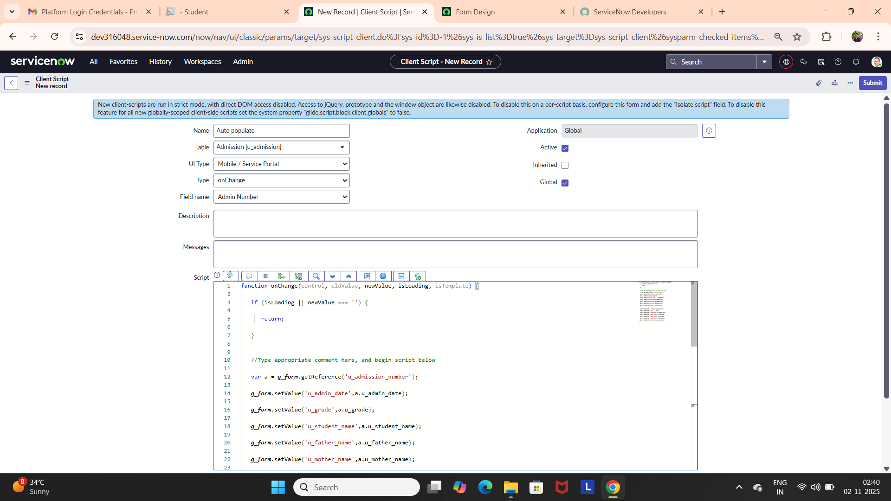

Creating “Pincode Update” Client Scripts for Admission Table
- Fill the Details.
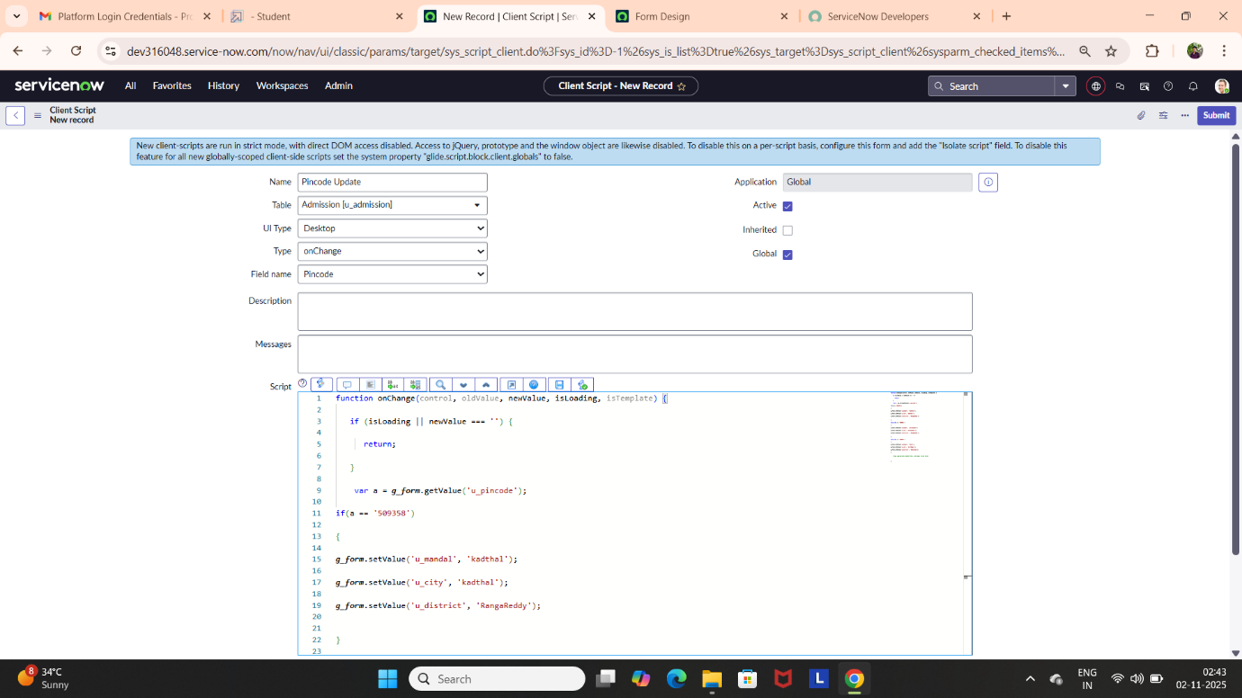
- Write the code, Enable Isolate Script and Save.

Creating “Disable Fields” Client Scripts for Student progress Table
- Fill the Details.
- Write the code, Enable Isolate Script and Save.
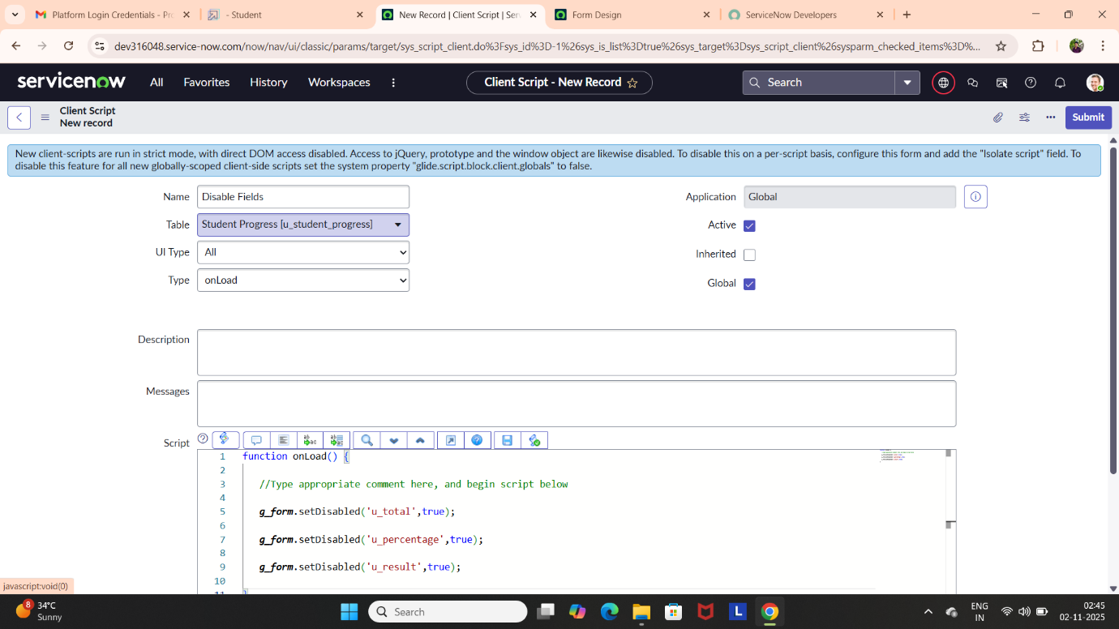

Creating “Total Update” Client Scripts for Student progress Table
- Fill the Details.
- Write the code, Enable Isolate Script and Save.
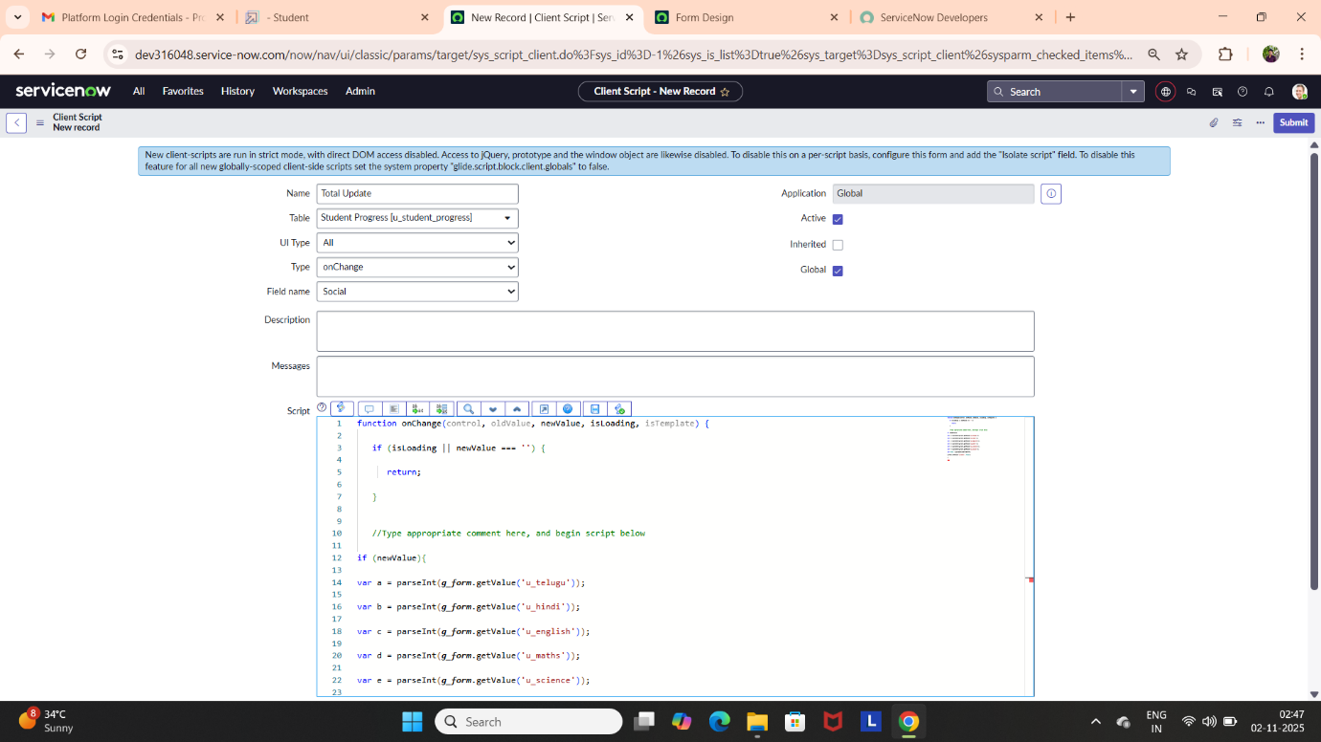

Creating “Result” Client Scripts for Student progress Table
- Fill the Details.
- Write the code, Enable Isolate Script and Save.
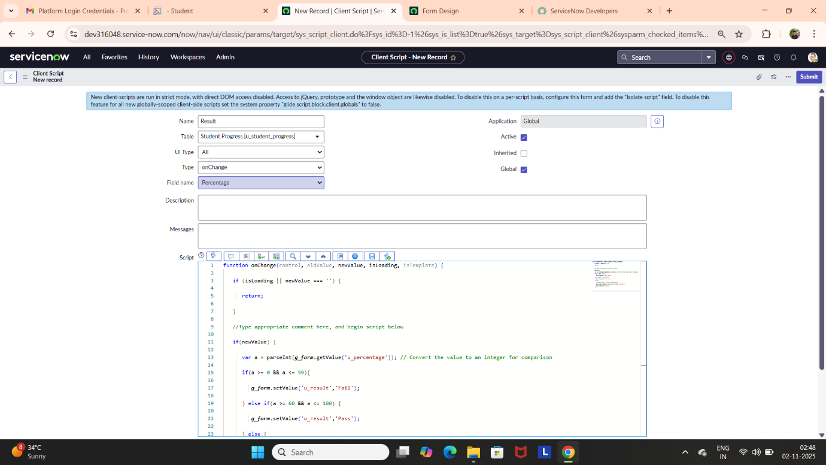

Creating “Percentage” Client Scripts for Student progress Table
- Fill the Details.
- Write the code, Enable Isolate Script and Save.
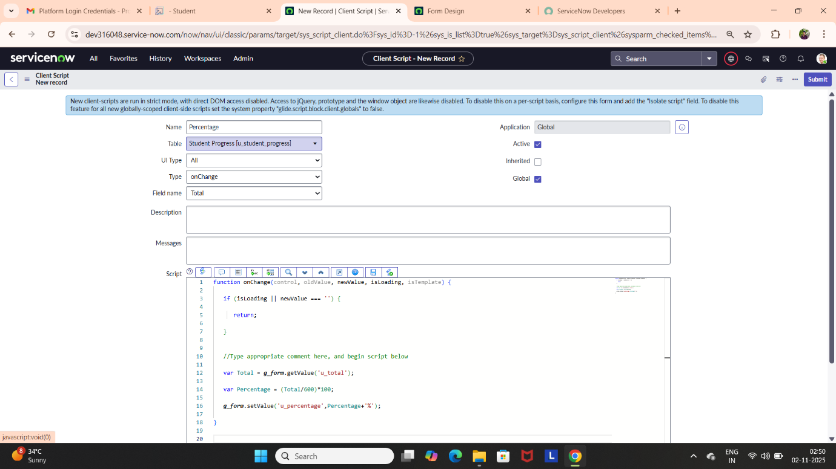

- Output & Result

Salesforce Table Form:
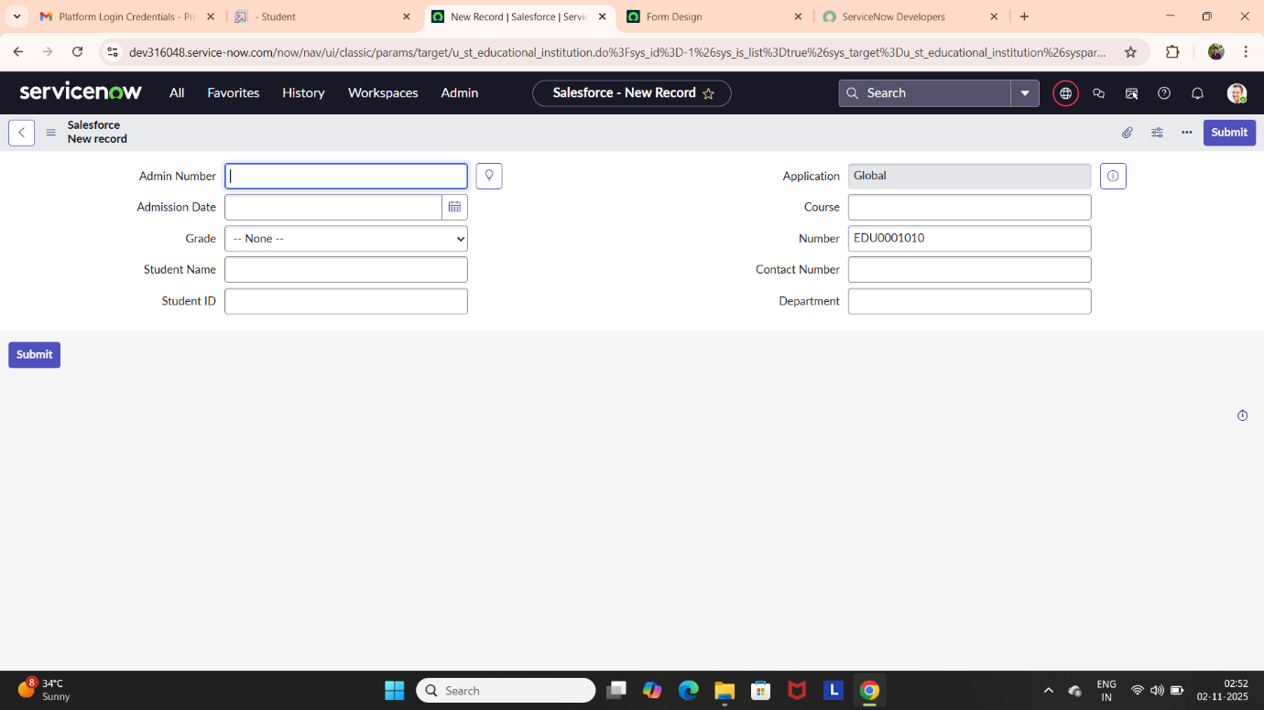

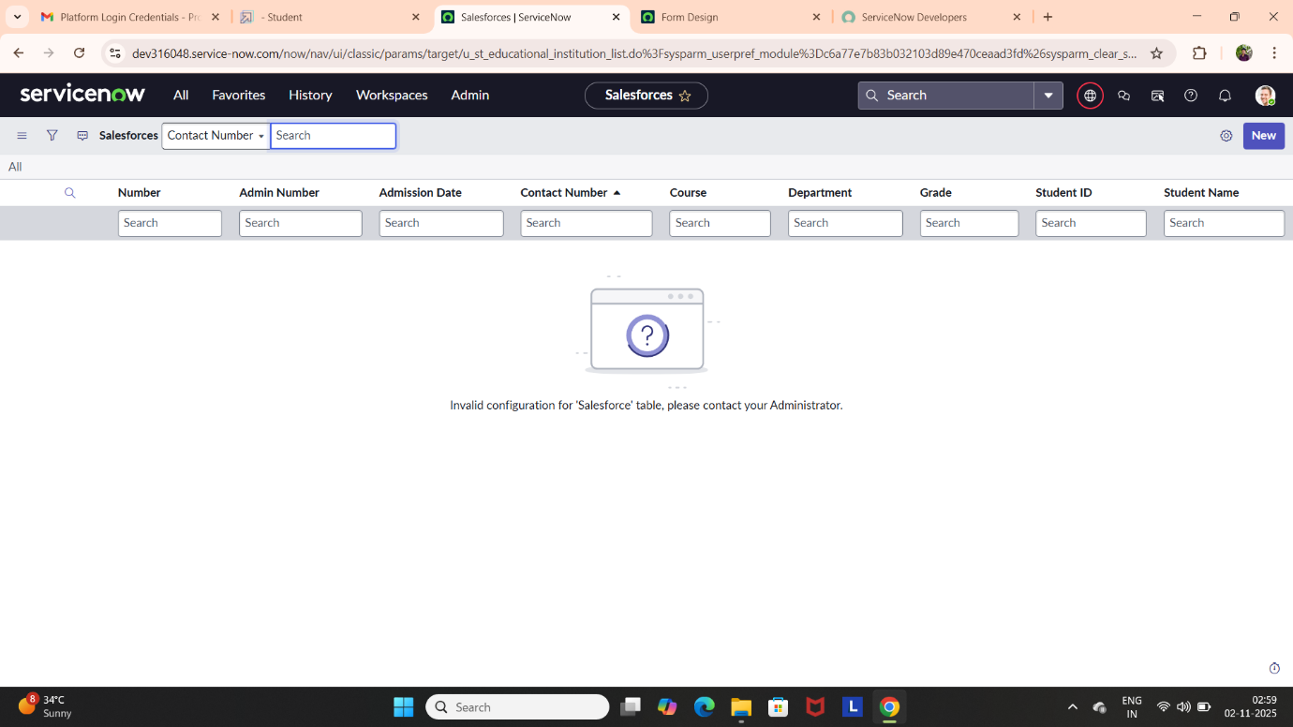

Admission Table Form:
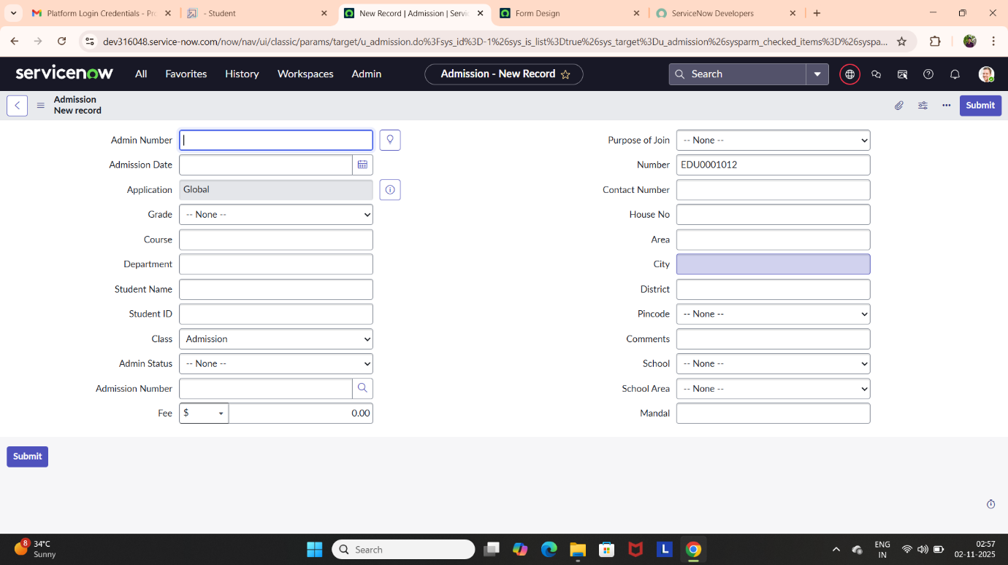

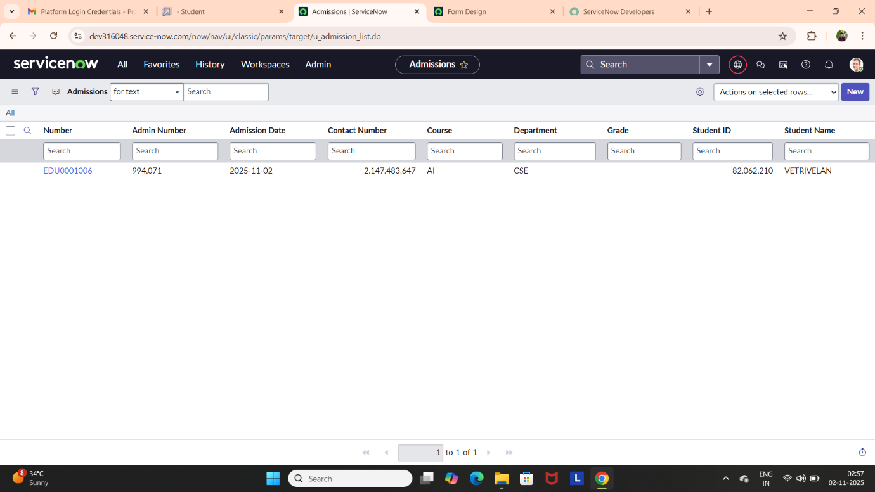

Student Progress Table Form:
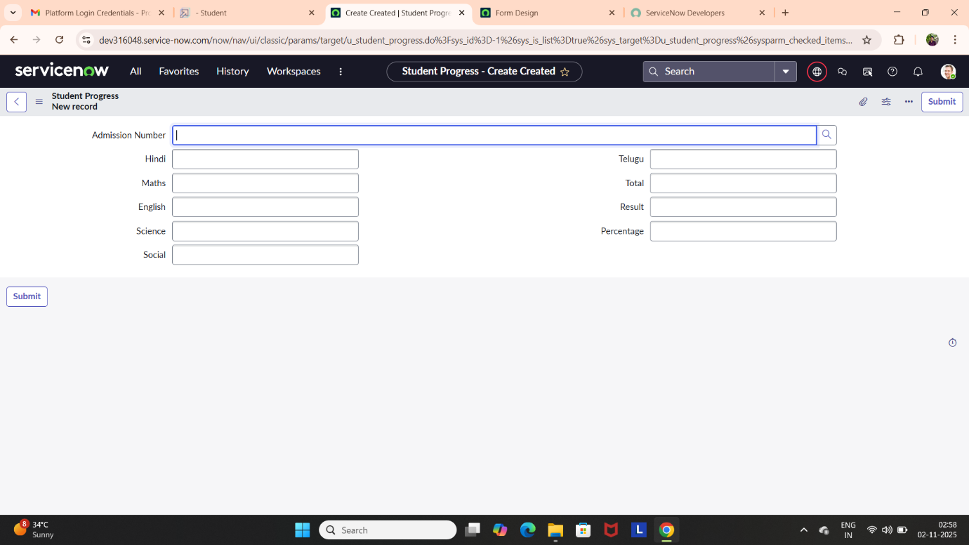

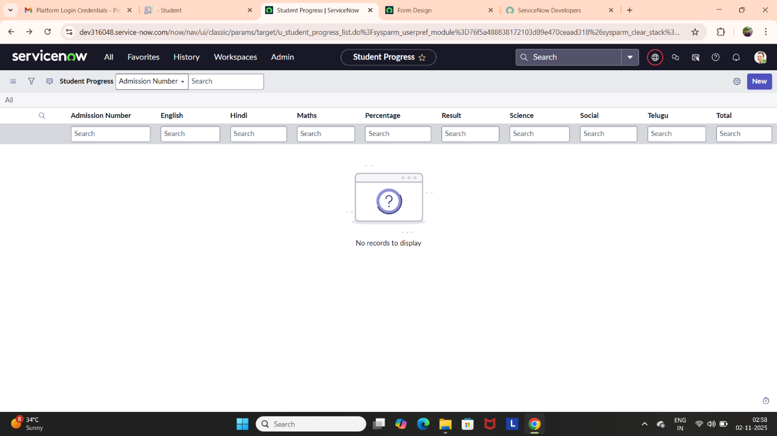

Results and Discussion:
The ServiceNow automation system was successfully implemented for the educational institution. All service requests, including IT and administrative issues, were effectively tracked and resolved. The workflow automation improved the speed and accuracy of service management. Screenshots show proper functioning of tables, forms, and workflows within the platform. The project achieved its goal of creating a transparent and centralized service system. Overall, performance testing confirmed reliability and user satisfaction.
Conclusions:
This project successfully demonstrated the use of ServiceNow in automating institutional service processes. It replaced time-consuming manual tasks with efficient automated workflows. The system ensured better communication between students, staff, and administrators. Faster service delivery and improved accuracy enhanced overall productivity. Hence, the ServiceNow-based solution proved to be effective, reliable, and scalable for educational use.

